|  |  |  |
| --- | --- | --- |
|  |  | French Agency for State Financial Information Technology |
| 31/07/2023 |
|  |
| External specification file for electronic invoicing  Use cases | | |
|  | | |
|  | | |
|  | | |

Contents

1. Overview 4

1.1 Overview of invoicing circuits and parties 4

1.2 Presentation of the annexes used in the use cases 4

1.3 Presentation of invoices taken into account in use cases 6

2 Description of the main use cases 6

2.1 Use case summary table 6

2.2 Processing of major cases 8

2.2.1 Case no. 1 : Multi-order / Multi-delivery 8

2.2.2 Case 2 : invoice already paid by the buyer or a third party known at the time of invoicing 8

2.2.3 Case no. 3 : Invoice to be paid by a third party designated at the time of invoicing 9

2.2.4 Case 4 : Invoice to be paid by the buyer and partially paid by a third party known at the time of invoicing (subsidy, insurance, etc.) 11

2.2.5 Cases Nos. 5 and 6 : Costs paid by employees (other than purchase or corporate cards), with an invoice in the company's name (e-invoicing) or without an invoice (simple cash register receipt) (e-reportingof off-invoice transaction data) 13

2.2.6 Case 7 : Invoice following purchase with a corporate card (purchase card) 14

2.2.7 Cases 8 to 10 : Invoices payable to a third party (including factoring) 15

2.2.8 Case no. 11 : Invoice with INVOICEE other than BUYER 21

2.2.9 Case 12 : Transparent intermediary as invoice manager for the buyer principal 23

2.2.10 Cases Nos. 13 and 14 : Case of subcontracting and co-contracting (B2B/B2C) 24

2.2.11 Case 15 : Sales invoice following order/payment of a third party on behalf of the BUYER 32

2.2.12 Case no. 16 : Disbursement invoice for reimbursement of the sales invoice paid by the third party 34

2.2.13 Case no. 17a : Invoice payable to a third party, payment intermediary (e.g. on Marketplace) 34

2.2.14 Case no. 17b : Invoice payable to a third party, payment intermediary and billing mandate 36

2.2.15 Case 18 : Debit note management 37

2.2.16 Case 19a : Invoice issued with billing mandate 38

2.2.17 Case no. 19b : Self-billing 42

2.2.18 Cases 20 and 21 : Prepayment invoice and final invoice after prepayment 45

2.2.19 Case 22a : Invoice paid with discount on supply of services for which VAT is due on receipt of payment 47

2.2.20 Case no. 22b : Invoice paid with discount in the case of delivery of goods (or supply of services with the option to pay VAT on debits) 49

2.2.21 Case 23 : Self-billing flow between a private individual and a professional 50

2.2.22 Case 24 : Management of deposits 50

2.2.23 Case no. 25 : Management of gift vouchers and gift cards 50

2.2.24 Case 26 : Invoices with contractual reserve clause 53

2.2.25 Case 27 : Management of toll receipts 53

2.2.26 Case 28 : Management of restaurant bills 54

2.2.27 Case 29 : Single taxable entity as defined in Article 256 C of the CGI 55

2.2.28 Case no. 30 : VAT already collected - Transactions initially processed under B2C e-reporting, subject to subsequent invoicing 56

2.2.29 Case 31 : "Mixed" invoices mentioning a main transaction and an accessory transaction 57

2.2.30 Case 32 : Monthly payments 60

2.2.31 Case 33 : Transactions subject to the VAT margin scheme 64

2.2.32 Case 34 : Partial receipt of payment and cancellation of receipt of payment 65

2.2.33 Case no. 35 : Author’s notes 66

2.2.34 Case 36 : Transactions subject to professional secrecy and exchange of sensitive data 66

3 Contacts 67

**Figures**

Figure 1 : invoice already paid by the buyer or a third party designated at the time of invoicing 8

Figure 2 : Invoice to be paid by a designated third party 9

Figure 3 : Invoice to be paid by the buyer and partially processed by a third party known at the time of invoicing (subsidy, insurance, etc.) 10

Figure 4 : Costs paid by employees 12

Figure 5 : Invoice following purchase with a corporate card 12

Figure 6 : Invoice to be paid to a third party designated at the time of invoicing (Option 1) 14

Figure 7 : Invoice to be paid to a third party designated at the time of invoicing (Option 1) 16

Figure 8 : Invoice to be paid to a third party designated at the time of invoicing (Option 2) 17

Figure 9 : Invoice payable to a third party unknown at the time of invoicing 18

Figure 10 : Invoice with “addressed to” (INVOICEE) other than the buyer (BUYER) 20

Figure 11 : Transparent intermediary 22

Figure 12 : Invoice (F1) to be paid by a third party (case of subcontracting by delegation in B2B) 24

Figure 13 : Invoice (F2) to be paid by a third party (case of subcontracting by delegation in B2B) 24

Figure 14 : Invoice payable by a third party (case of subcontracting with direct payment in B2G) 25

Figure 15 : Invoice to be paid by a third party (B2B co-contracting) 27

Figure 16 : Invoice to be paid by a third party (B2G co-contracting) 28

Figure 17 : Sales invoice following an order / payment from a Third Party on behalf of the buyer (media purchase, consultancy fees) 29

Figure 18 : Invoice payable to a third party, payment intermediary 31

Figure 19 : Invoice payable to a third party, payment intermediary and billing mandate 33

Figure 20 : Invoice issued with billing mandate (option 1) 35

Figure 21 : Invoice issued with billing mandate (option 2) 37

Figure 22 : Self-billing 39

Figure 23 : Prepayment invoice and final invoice after prepayment 41

Figure 24 : Invoice paid with discount (for supply of service, VAT payable on collection) 43

Figure 25 : Invoice paid with discount (delivery of goods, supply of service with VAT on debits) 45

Figure 26 : Management of single-use vouchers 47

Figure 27 : Management of multiple-use vouchers 48

Figure 28 : Management of restaurant bills 49

Figure 29 : Declaration of transaction data for bills below 150 euros 50

Figure 30 : Issuance/transmission of an electronic invoice for notes exceeding €150 50

Figure 31 : Management of duplicate invoices 52

Figure 32 : Mixed invoice with main and accessory transactions categorised as a sale (case of a sales adjustment) 53

Figure 33 : Invoice with main transaction = PS (case of adjustment with or without sale) 54

Figure 34 : Monthly payments and supplement to be paid as part of a B2C transaction (Option 1a) 55

Figure 35 : Monthly B2C payments and top-up (option 1b) 56

Figure 36 : Monthly payments and overpayments in a B2C transaction (option 2.a) 57

Figure 37 : Monthly payments and final overpayments in a B2C transaction (option 2.b) 58

Figure 38 : Transactions subject to the VAT margin scheme 59

# Overview

## Overview of invoicing circuits and parties

The following use cases exist in three possible circuits (described in the “Y” scheme section) on the public invoicing portal :

* Circuit A
* Circuit B
* Circuit C

In most cases, the operation is illustrated with circuit C.

Various actors play a role :

* The supplier supplies the product or service that is the subject of an invoice,
* The buyer is the one who purchased the product or service ; in most cases, he pays the invoice received from the supplier or third party,
* The subcontractor delivers the product or performs the service offered by the supplier/principal,
* The third party is an intermediary entity between the parties on the invoice. It can be a third party issuing the invoice, a third party receiving the invoice, a third party paying, etc.
* PDPs are registered private platforms used by the supplier, third party or buyer,
* The PPF is the public invoicing portal.

## Presentation of the annexes used in the use cases

These use cases are based on the following annexes to the external specifications :

* "Annexe 1 – Format sémantique FE e-invoicing.xlsx", including the following tabs :
  + Version : identification of changes in the various versions of the Annex
  + N.B. : explanations about how the file works
  + FE - Flow 2 - UBL : semantic format for UBL for flow 2
  + FE - Flow 1 - UBL : semantic format for UBL for flow 1
  + FE - Flow 2 - CII : semantic format for CII for flow 2
  + FE - Flow 1 - CII : semantic format for CII for flow 1
  + Factur-X FR CII D16B - Flow 2 : semantic format for Factur-X for Flow 2
  + Factur-X FR CII D16B - Flow 1 : semantic format for Factur-X for Flow 1
* "Annexe 2 – Format sémantique FE CDV – Flux 6.xlsx", including the following tabs :
  + Version : identification of changes in the various versions of the Annex
  + N.B. : explains how the file works
  + Life cycle FE - CI ARM : semantic format of the life cycle message
  + Statuses : summary of possible statuses by business object
* "*Annexe 3 - Format sémantique FE annuaire.xlsx*" including :
* Version : identification of changes in the various versions of the Annex
* N.B. : explains how the file works
* FE Directory Flow
* "Annexe 4 – Format sémantique FE e-reporting - Flux 8.xlsx", with the following tabs :
  + Version : identification of changes in the various versions of the Annex
  + N.B. : explains how the file works
  + B2B - Flow 8 – UBL : semantic format for UBL
  + B2B - Flow 8 – CII : semantic format for CII
  + Factur-X FR CII D16B – Flow 8 : semantic format for factur-X

* "Annexe 5 – Format sémantique FE e-reporting - Flux 9.xlsx", with the following tabs :
  + Version : identification of changes in the various versions of the Annex
  + N.B. : explains how the file works
  + B2B - Flow 9 – UBL : semantic format for UBL
  + B2B - Flow 9 – CII : semantic format for CII
  + Factur-X FR CII D16B – Flow 9 : semantic format for Factur-X

* "Annexe 6 - Format sémantique FE e-reporting - Flux 10.xlsx", with the following tabs :
  + Version : identification of changes in the various versions of the Annex
  + N.B. : explains how the file works
  + E-REPORTING - Flow 10

* "Annexe 7 – Règles de gestion.xlsx", including the following tabs :
  + Version : identification of changes in the various versions of the Annex
  + Public invoicing portal management Rules : Specific management rules
  + Standard EN16931 rules : Management rules of the standard
  + EN16931 Code lists : Repositories available for each data item (BT) resulting in a repository
  + Table of reasons for refusal : Detailed description of the reasons for refusal of an invoice

## Presentation of invoices taken into account in use cases

In the framework of dematerialised exchange of domestic B2B invoices, several types of invoices are taken into account :

Simple invoices :

* Commercial invoice ;
* Self-billed invoice,
* Factored invoice (subject to assignment of receivables) ;
* Factored self-billed invoice ;

Prepayment invoices :

* Prepayment invoice ;
* Self-billed prepayment invoice ;

Correcting invoices :

* Correcting invoice ;
* Self-billed correcting invoice ;
* Factored correcting invoice ;
* Factored self-billed correcting invoice ;

Credit notes :

* Credit note ;
* Self-billed credit note ;
* Factored credit note ;
* Factored self-billed credit note ;
* Prepayment invoice credit note ;

Discounts :

* Global discounts (applicable only in B2G)

# Description of the main use cases

## Use case summary table

|  |  |  |
| --- | --- | --- |
| **Category** | **ID** | **Use case** |
| Multi-order / Multi-delivery | 1 | Case 1 : Multi-order / Multi-delivery |
| Invoice already paid by a Third Party or the buyer | 2 | Case 2 : Invoice already paid by the buyer or a third party known at the time of invoicing |
| Invoice to be paid by a third party | 3 | Case 3 : Invoice to be paid by a third party designated at the time of invoicing |
| 4 | Case 4 : Invoice to be paid by the buyer and partially paid by a third party known at the time of invoicing (subsidy, insurance, etc.) |
| Costs paid by third parties with invoice | 5 | Cases Nos. 5 and 6 : Costs paid by employees (other than purchase or corporate cards), with an invoice in the company's name (e-invoicing) or without an invoice (simple cash register receipt) (e-reporting of off-invoice transaction data) |
| Costs paid by third parties without invoice | 6 |
| Invoice paid by a Third Party | 7 | Case 7 : Invoice following purchase with a corporate card (purchase card) |
| Invoice payable to a Third Party | 8 | Case 8 : Invoice payable to a third party designated at the time of invoicing (factoring, cash pooling) |
| 9 | Case 9 : Invoice to be paid to a third party known at the time of invoicing, who also manages the order/receipt, or even the invoicing (Distributor / Depositary) |
| 10 | Case 10 : Invoice payable to a third party unknown at the time of invoicing (subrogation by a factor not known at the time of invoicing) |
| Invoice with "addressed to" different from buyer | 11 | Case 11 : Invoice with INVOICEE different from BUYER |
| Transparent intermediary | 12 | Case 12 : Transparent intermediary as invoice manager for the buyer principal |
| Subcontracting invoice for direct payment | 13 | Case 13 : Invoice to be paid by a third party (in case of subcontracting with direct payment or payment delegation) |
| Co-contracting invoice | 14 | Case 14 : Invoice to be paid by a third party (co-contracting) |
| Invoice following an order / payment from a Third Party on behalf of the buyer | 15 | Case 15 : Sales invoice following order/payment of a third party on behalf of the BUYER |
| 16 | Case 16 : Disbursement invoice for reimbursement of the sales invoice paid by the third party |
| Invoice issued by a third party, payment intermediary | 17a | Case 17a : Invoice payable to a third party, payment intermediary (e.g. on Marketplace) |
| Invoice issued by third party, payment intermediary and billing mandate | 17b | Case 17b : Invoice payable to a third party, payment intermediary and billing mandate |
| Debit notes | 18 | Case 18 : Debit note management |
| Invoices issued under a third-party mandate | 19a | Case 19a : Invoice issued with billing mandate |
| Self-billing | 19b | Case 19b : Self-billing |
| Prepayment invoice | 20 | Cases 20 and 21 : Prepayment invoice and final invoice after prepayment |
| 21 |
| Invoice with discount | 22a | Case 22a : Invoice paid with discount on supply of services for which VAT is due on receipt of payment |
| 22b | Case 22b : Invoice paid with discount in the case of delivery of goods (or supply of services with the option to pay VAT on debits) |
| Self-billing between a private individual and a professional | 23 | Case 23 : Self-billing flow between a private individual and a professional |
| Deposit | 24 | Case 24 : Management of deposits |
| Gift cards and vouchers | 25 | Case 25 : Management of gift vouchers and gift cards |
| Invoices with contractual reserve clause | 26 | Case 26 : Invoices with contractual reserve clause |
| Toll receipts | 27 | Case 27 : Management of toll receipts |
| Restaurant bills | 28 | Case 28 : Management of restaurant bills |
| Single taxable entity and members of the single taxable entity | 29 | Case 29 : Single taxable entity as defined in Article 256 C of the CGI |
| E-reporting transaction covered by an invoice or "VAT already collected" | 30 | Case 30 : VAT already collected - Transactions initially processed under B2C e-reporting, subject to subsequent invoicing |
| Mixed invoices | 31 | Case 31 : "Mixed" invoices mentioning a main transaction and an accessory transaction |
| Management of monthly payments | 32 | Case 32 : Monthly payments |
| VAT margin scheme | 33 | Case 33 : Transactions subject to the VAT margin scheme |
| Partial receipt of payment and cancellation of receipt of payment | 34 | Case 34 : Partial receipt of payment and cancellation of receipt of payment |
| Author’s notes | 35 | Case 35 : Author's notes |
| Professional secrecy | 36 | Case 36 : Transactions subject to professional secrecy and exchange of sensitive data |

## Processing of major cases

### Case no. 1 : Multi-order / Multi-delivery

Currently it is not possible to send multi-order / multi-delivery invoices under standard EN16931.

The EXT-FR-FE-BG-10 extension can be used to enter information (see General document, §3.2.6.1) the following information in the invoice at line level (Block BG-25) :

* Order No.
* Delivery (Name, site ID, address information)

### Case 2 : invoice already paid by the buyer or a third party known at the time of invoicing

For this management case, two sub-cases should be considered :

1. Invoice already paid by the buyer
2. Invoice already paid by a third party (addition of a party to the process)

The data specifics and associated management rules are :

* Invoicing framework “Submission of an invoice already paid”
* Due date is identical to payment date
* Amount paid (BT-113) is equal to the total invoice amount
* Amount payable (BT-115) is equal to 0
* In sub-case 2, the third party who has already paid the invoice must be entered in the "PAYER OF THE INVOICE" block (EXT-FR-FE-BG-02).
* The supplier receives the invoice statuses, so that it can indicate the receipt of invoice payment and update the "payment received" status sent to the public invoicing portal.

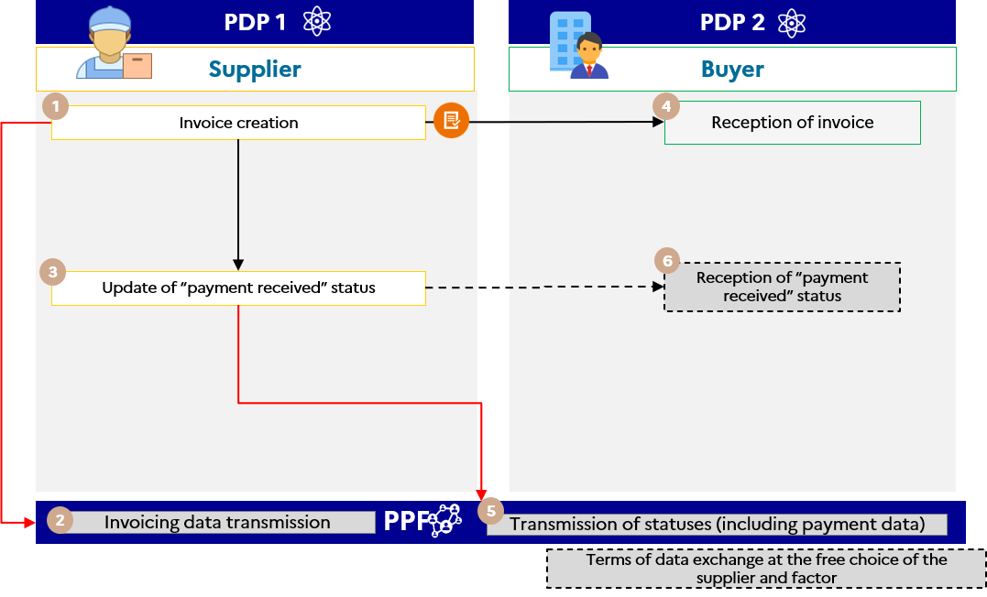

Figure 1 : invoice already paid by the buyer or a third party designated at the time of invoicing

The specifics of the associated life cycle or process are :

* Transmission of flow 1 by the supplier
* The fact that the invoice is already paid does not exempt the supplier from forwarding the e-reporting flow of payment data ("payment received" status) when the transaction falls within the supply of services category
* “Payment received” status can be addressed simultaneously with issuing of the invoice

### Case no. 3 : Invoice to be paid by a third party designated at the time of invoicing

The invoice is sent by the supplier to the buyer, who is responsible for forwarding it to the third-party payer after settlement or validation.

For all invoices submitted by the public invoicing portal or a registered private platform :

* The third-party payer can be identified on the invoice in the "INVOICE PAYER" block (EXT-FR-FE-BG-02).
* On the public invoicing portal, the invoice and its life cycle are not transmitted to the third-party payer ; they will be made available to him if he has an account on Chorus Pro.
* The registered private platforms are responsible for managing access to the third-party payer life cycle.
* The life cycle can be updated by the third-party payer via a registered private platform or directly on the public invoicing portal.

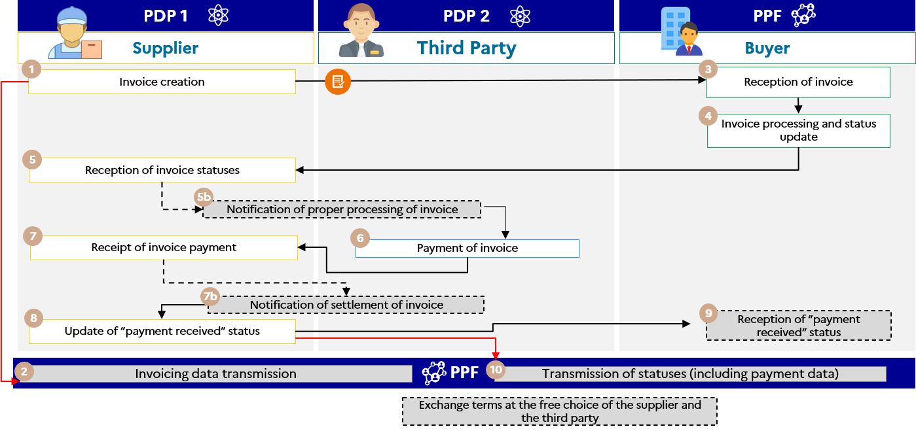

Figure 2 : Invoice to be paid by a designated third party

The specifics of the associated life cycle or process are :

* The life cycle can be updated by the third-party payer directly on the public invoicing portal or via one of the registered private platforms. An account on one of these platforms will be required
* Transmission of flow 1 and e-reporting of the payment data by the supplier

The services offered by the public invoicing portal are :

* If the buyer and the third party are connected to the public invoicing portal, the public invoicing portal will have read-access to the invoice and its life cycle
* If the supplier and the third party are connected to the public invoicing portal, the public invoicing portal will have read-access to the invoice and its life cycle
* Parties who are connected to the public invoicing portal will be notified via the issue of a life cycle flow in case of a change in the status of the invoice.

The steps in case no. 3 are :

|  |  |  |  |
| --- | --- | --- | --- |
| **Step** | **Step name** | **Party responsible** | **Description** |
| 1 | Invoice creation | Supplier | The supplier creates the invoice (Flow 2) via registered private platform 1, which sends it to the buyer. registered private platform 1 sends the invoice payment data (flow 1) in parallel to the public invoicing portal. |
| 2 | Reception of flow 1 | public invoicing portal |
| 3 | Reception of invoice | Buyer | The buyer's platform (the public invoicing portal in the example) makes the invoice available for control. The buyer processes the invoice in accordance with the procedure and updates the statuses. |
| 4 | Invoice processing and status update |
| 5 | Reception of invoice statuses | Supplier | The supplier receives the invoice statuses after the invoice has been processed by the buyer in accordance with the life-cycle procedures. |
| 5b | Notification of proper processing of invoice | Supplier | The supplier provides information on the proper processing of the invoice. (depending on the commercial offer of the platforms) |
| 6 | Payment of invoice | Third Party | The third party pays the supplier |
| 7 | Receipt of invoice payment | Supplier | 1. The supplier cashes the invoice and updates the receipt of invoice payment information using the "payment received" status  2. The supplier's registered private platform 1 forwards the payment data to the public invoicing portal.  3. Depending on the commercial offer of the platforms, it can send a receipt of payment life cycle to the third party and/or the buyer. |
| 7b | Notification of settlement of invoice | Supplier |
| 8 | Update of “payment received” status | Supplier |
| 9 | Reception of “payment received” status | Buyer | The buyer's platform (public invoicing portal in the example) receives the receipt of payment status transmitted by the supplier's registered private platform 1. |

### Case 4 : Invoice to be paid by the buyer and partially paid by a third party known at the time of invoicing (subsidy, insurance, etc.)

This management case covers invoices partially paid by a third party (for example, a repair invoice where the co-payment is paid by a customer and the balance by the insurer).

In view of the current provisions of EN16931 and the CII and UBL formats, it is not possible to establish a payment schedule identifying the various payments and the parties involved.

Therefore, the data specifics and associated management rules are :

* The SELLER block (BG-4) is used to populate supplier information.
* The BUYER block (BG-7) is used to provide information about the customer to pay the invoice (for example, the company that has to pay an exemption).
* The INVOICE PAYER block (EXT-FR-FE-BG-02) is used to mention the third party on the invoice (e.g. the insurance). When the PAYER block is filled in, if the third party has an account on the PUBLIC INVOICING PORTAL, he will be able to read the invoice (excluding circuit C).
* The AMOUNT PAID (BT-113) field is used to enter the amount of the invoice that has already been paid or will be payable by a third party (e.g. the amount of the invoice paid by the insurer).
* The INVOICE NOTE (BG-1) block is used to indicate that a portion of the invoice has already been paid or will be payable by one or more third parties. In particular, in the INVOICE NOTE SUBJECT CODE (BT-21) field, the supplier must enter the PAI code to specify payment information.
* The supplier will have to report 2 receipts of payment : one from the customer, the other from the third party known at the time of invoicing.

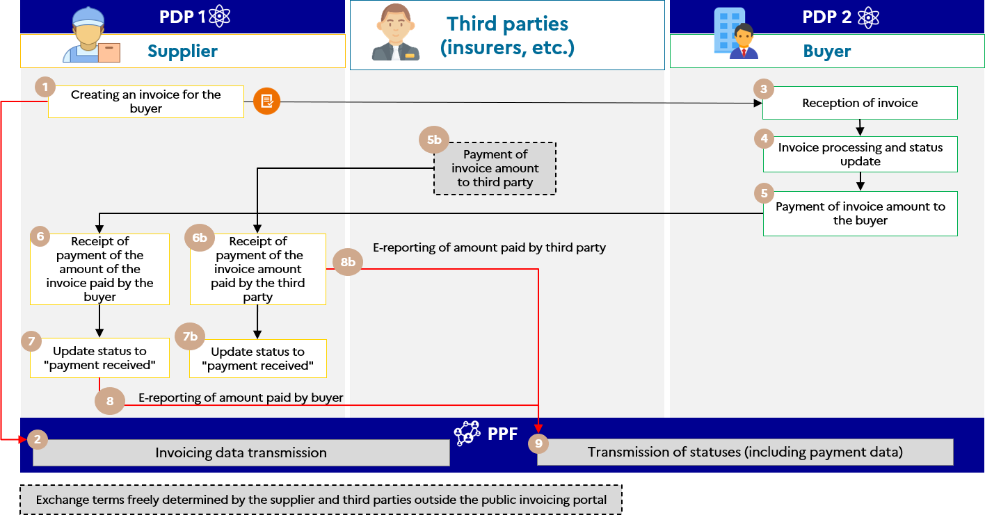

Figure 3 : Invoice to be paid by the buyer and partially paid by a third party known at the time of invoicing (subsidy, insurance, etc.)

The steps in case 4 are :

|  |  |  |  |
| --- | --- | --- | --- |
| **Step** | **Step name** | **Party responsible** | **Description** |
| 1 | Creating an invoice for the buyer | Supplier | The supplier or its registered private platform creates the invoice to be transmitted to the buyer (or the buyer's registered private platform), specifying the amount paid by the third party. The same invoice, which can be sent to the third party, is not part of the public invoicing portal invoicing circuit. |
| 2 | Receiving data from flow 1 | public invoicing portal | In the case of circuits A, B1 and B2, the supplier or its registered private platform transmits the data from flow 1 to enable the public invoicing portal to generate the flow for the tax authority.  In the case of circuit C, the supplier's registered private platform generates this flow directly for the public invoicing portal for transmission, after control, to the tax authority. |
| 3 | Reception of invoice | Buyer | The buyer receives the invoice directly from the public invoicing portal or through its registered private platform. |
| 4 | Invoice processing and status update | Buyer | The buyer or the buyer's registered private platform acknowledges receipt of the invoice and, where applicable, transmits the appropriate statuses to the supplier or its registered private platform. |
| 5 | Payment of invoice | Buyer | The buyer or his registered private platform pays the amount of the invoice payable by him, and updates the invoice payment information. |
| 5b | Payment of invoice | Third Party | The third party pays the amount of the invoice payable by him (off the invoicing circuit of the public invoicing portal). |
| 6 | Receipt of payment of the amount of the invoice paid by the buyer | Supplier | The supplier collects the amount of the invoice paid by the buyer and the third party, and updates the receipt of invoice payment information.  Depending on the commercial offer of the platforms, it can send a life cycle of the receipt of payment to the buyer.  The supplier or its registered private platform transmits payment data to the public invoicing portal in 2 steps, following the receipts of payment of the amounts paid by the buyer and the third party. |
| 6b | Receipt of payment of the invoice amount paid by the third party | Supplier |
| 7 | Update of the "payment received" status | Supplier |
| 7b | Transmission of buyer payment data | Supplier |
| 7c | Transmission of third-party payment data | Supplier |
| 8 | Receipt of e-reporting flow payment data | public invoicing portal | The public invoicing portal receives the payment data flow sent, first by collecting the amount of the invoice amount paid by the third party and then by collecting the amount of the invoice paid by the buyer. |

### Cases Nos. 5 and 6 : Costs paid by employees (other than purchase or corporate cards), with an invoice in the company's name (e-invoicing) or without an invoice (simple cash register receipt = e-reportingof off-invoice transaction data)

This management case covers advances made by a worker in the course of his professional activity and for which an invoice on behalf of the company has been issued.

In this case, the employees incur the expenses and the company reimburses them. This is only valid if the invoice paid by the employee is made out in the name of the company and is therefore subject to an electronic invoice. The employees are then considered as third-party payers ; it can be indicated in the "PAYER OF THE INVOICE" block (EXT-FR-FE-BG-02).

* Invoices paid by the employee not in the name of the company must be declared by the supplier as B2C, and are therefore subject to e-reporting. It is therefore not declared under B2B and is not subject to an electronic invoice.

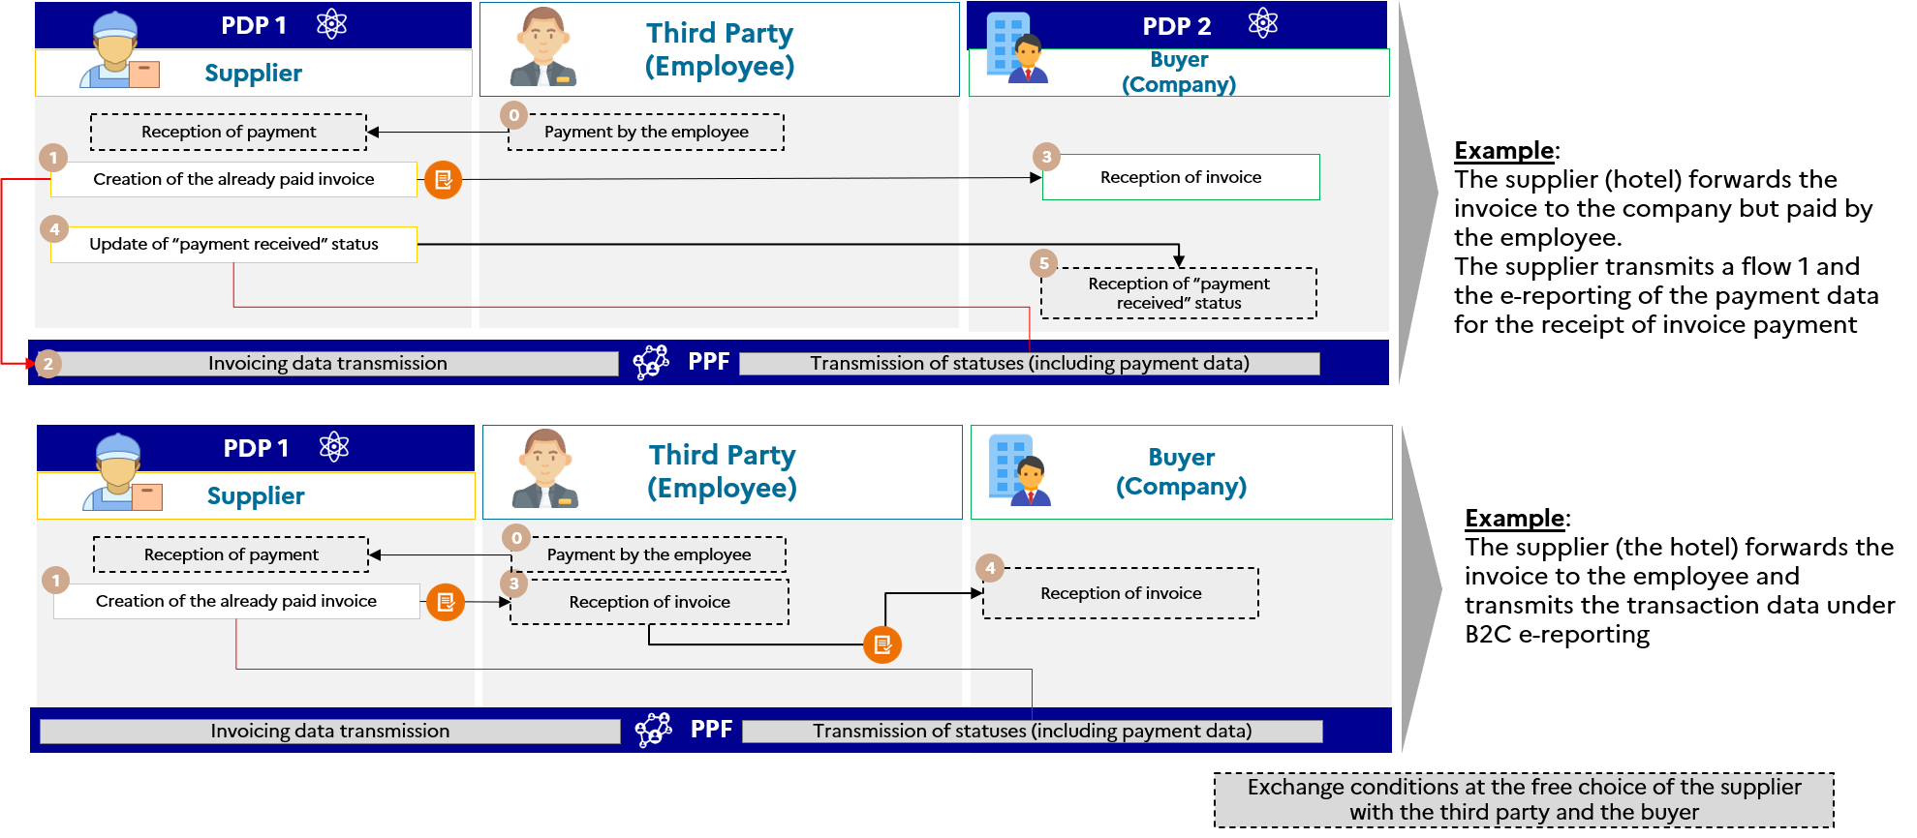

Figure 4 : Costs paid by employees

### Case 7 : Invoice following purchase with a corporate card (purchase card)

In the case of a purchase with a corporate card for a hotel room or train tickets paid by the public entity/accountant, for example, this is an invoice already paid (BT-113) and the due date is indicated with the payment date.

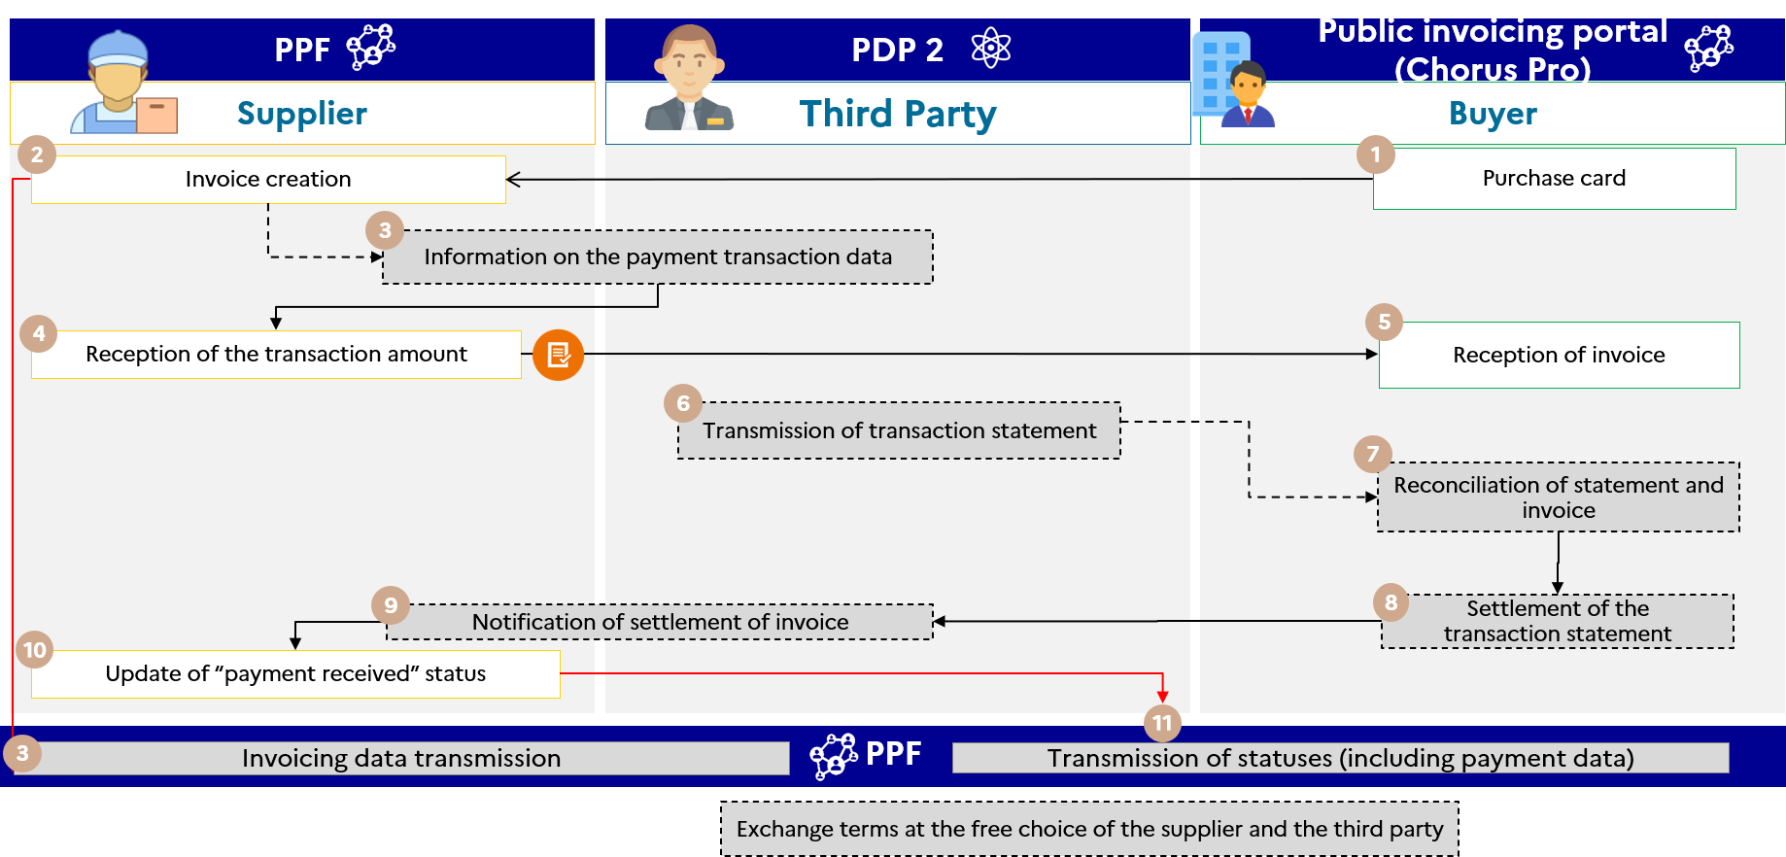

Figure 5 : Invoice following purchase with a corporate card

The steps in case no. 7 are :

|  |  |  |  |
| --- | --- | --- | --- |
| **Step** | **Step name** | **Party responsible** | **Description** |
| 1 | Purchase card | Buyer | The buyer orders a product/trip from the supplier using a purchase card or corporate card |
| 2 | Invoice creation | Supplier | The supplier creates the invoice that has already been paid. Its transmit platform (public invoicing portal) sends a parallel flow 1 to declare invoicing data. |
| 3 | Information on the payment transaction data | Supplier | The data relating to the payment transaction is transmitted to the financial institution (off-tool). |
| 4 | Reception of the transaction amount | Supplier | The supplier receives the invoice payment. |
| 5 | Reception of invoice | Buyer | The buyer receives the invoice from his supplier. |
| 6 | Transmission of transaction statement | Third Party | The institution sends a statement of transactions to the client (off-tool). |
| 7 | Reconciliation of statement and invoice | Buyer | The customer can reconcile invoices received from the supplier with the transaction statement. |
| 8 | Settlement of the transaction statement | Buyer | The buyer settles the transaction statement (off-tool) |
| 9 | Notification of receipt of invoice payment |
| 10 | Update of “payment received” status | Supplier | The public invoicing portal therefore sends the "payment received" status via a flow 6 (payment data to the tax authority). This declaration may be made automatically (without any action by the supplier) following receipt of the invoice. |
| 11 | Receipt of the payment data flow |

In the context of a B2B transaction, a corporate card operates as in Case 2 : invoice already paid by the buyer or a designated third party at the time of issue of the invoice.

### Cases 8 to 10 : Invoices payable to a third party (including factoring)

#### Focus on factoring management on the public invoicing portal

Factoring is a credit transaction within the meaning of Article l. 313-1 of the Monetary and Financial Code. This regulated financial service, provided by specialist credit institutions or finance companies, is based on the purchase of commercial receivables. The legal principal underlying the transfer of receivables from the supplier to the factor is the contractual subrogation provided for by the civil code, the assignment of professional receivables under the “Dailly assignment” mechanism provided for by the monetary and financial code, or the assignment of receivables provided for by the civil code. Regardless of the legal foundations, the factor is the owner of the assigned debt.

**Prerequisites** :

Parties wishing to benefit from the services of the public invoicing portal must have a user account on the portal. A connection will also be required to exchange data flows (invoices or life cycles) or use the provided APIs. In the absence of such a connection, only the functionality offered by the portal will be available.

The services associated with factoring are available in the four cases summarized below.

**1st case :** The factor has an account on the public invoicing portal and the supplier and/or buyer use(s) the public invoicing portal to issue or receive the invoice.

|  |  |
| --- | --- |
| Figure 6 : Invoice to be paid to a third party designated at the time of invoicing (Option 1) | * The factor will be able to view the invoice and its life cycle : * The factor will be able to use portal/API solutions (if it has created a connection) to view the invoice and its lifecycle. * The factor will be able to update the life cycle (add attachment/receipt) : * The factor can use the portal/API channels (if it has created a connection) to update the lifecycle ; * The factor will be able to use the EDI or API channel to transmit a lifecycle update, if it has created the appropriate connection. * The public invoicing portal sends a notification (e-mail) to all parties with a user account as soon as an event affects the invoice (deposit/change of status/factored/change of factor) without actually specifying the type of event, instructing the parties concerned to come and consult the invoice to see the details of the event * Possibility of searching (with criteria) via API (if a connection has been made)[1]. In the event of changes to the invoices being searched, the public invoicing portal will send an API message containing the output data of the search[2]API. |

**2nd case** : The factor does not have an account on the public invoicing portal but the supplier and/or the buyer use(s) the public invoicing portal to issue or receive the invoice.

|  |  |
| --- | --- |
|  | * The invoice must be sent off-tool by the supplier to the factor. * Depending on the service offering of its PDP, the factor may either transmit the “received“ status to the public invoicing portal for the invoice concerned, or transmit the information to the supplier, who will enrich the “received“ status. |

**3rd case** : The factor has an account on the public invoicing portal but neither the supplier nor the buyer uses the public invoicing portal to issue or receive its invoice.

|  |  |
| --- | --- |
|  | * The public invoicing portal will receive only Flow 1 (data for the tax authority) of the supplier's registered private platform. * The invoice must be sent off-tool by the supplier to the factor. * The factor is not informed of changes to the invoice (life cycle). * The factor must send the receipt of payment information to the supplier so the latter can enrich the “received” status of the invoice concerned |

**4th case** : Neither party has an account on the public invoicing portal.

|  |  |
| --- | --- |
|  | * The public invoicing portal will only receive flow 1 from the supplier’s registered private platform. * Solution based on registered private plateform service offerings. * Depending on the service offering of its registered private platform, the factor may either transmit the “received“ status to the supplier’s PDP for the invoice concerned, or transmit the information to the supplier, who will enrich the “received“ status. |

**Conditions for access by factors to factored invoices :**

* **In the case of factoring declared to the buyer at the time of issue of the invoice**, **regardless of the mode of factoring (subrogation, assignment of receivables or “Dailly”)**, the factor will be automatically informed by API or e-mail and will have access to the invoice.

* **In the case of factoring declared to the buyer after issue of the invoice, regardless of the mode of factoring (subrogation, assignment of receivables or “Dailly”)**, action by the issuing supplier is essential, with the transmission of a “factoring” life cycle recording changes to the invoice and the factor’s name and bank details given in an *ad hoc* block. The factor and the client can then be notified by e-mail. As a reminder, the invoice is not changed and the factor does not appear on the invoice.
* **In the case of confidential factoring, i.e. where the buyer has not been notified, and regardless of the method of factoring (subrogation, assignment of receivables or “Dailly”),** the supplier may only act by delegation on its account so that the factor remains “hidden” from the eyes of the client. It will be notified by e-mail as soon as the supplier’s delegation is enabled across the perimeter defined by the latter.

**Management of confidential factoring** :

* In this case, the submitted invoice makes no mention of factoring ;
* If the supplier and the factor are connected to the public invoicing portal, the supplier may authorize a third party to act on its structure (at the structure or service level) so that the factor can have access to all the invoices issued by this structure/service. The factor can update the life cycle in the same way as the supplier.

**Change of factor :**

* The supplier can report a change of factor via a life cycle ;
* The initial factor, the new factor and the buyer will be notified (by e-mail) of this change ;
* The initial factor will only continue to review the associated invoices and life cycle for which it was specified ;
* The new factor will be able to view invoices and issue life cycles ;
* The invoice is not changed, so the new factor does not appear on it.

#### Case no. 8 : Invoice payable to a third party designated at the time of invoicing (factoring, cash pooling)

The invoice must be paid to a third party designated at the time of invoicing. The receivable linked to the invoice is assigned to a bank or factor by the supplier under a contract. The invoice payment data should only be transmitted when the factor has received the payment from the customer and not when the supplier is paid by the factor (VAT chargeability rule).

The data specifics and associated management rules are :

* The factor must be entered in block BG-10 "BENEFICIARY"
* The details allowing payment of the factor by bank transfer in block BG-17 “TRANSFER”
* The invoice type in BT-3 must be set to 393 (Factored invoice).

The specifics of the associated life cycle or process are :

* Transmission of Flow 2 by the supplier's registered private platform to the buyer's registered private platform
* Generation and transmission of flow 1 to public invoicing portal (case of circuit C)
* For the transmission of the payment data e-reporting flow, two options are possible (depending on the commercial agreements between the supplier and the factor) :
  + Option 8-1 : the **supplier** transmits the payment data e-reporting flow
  + Option 8-2 : the **third-party factor** transmits the payment data e-reporting flow

Option 8-1 can be described as follows :

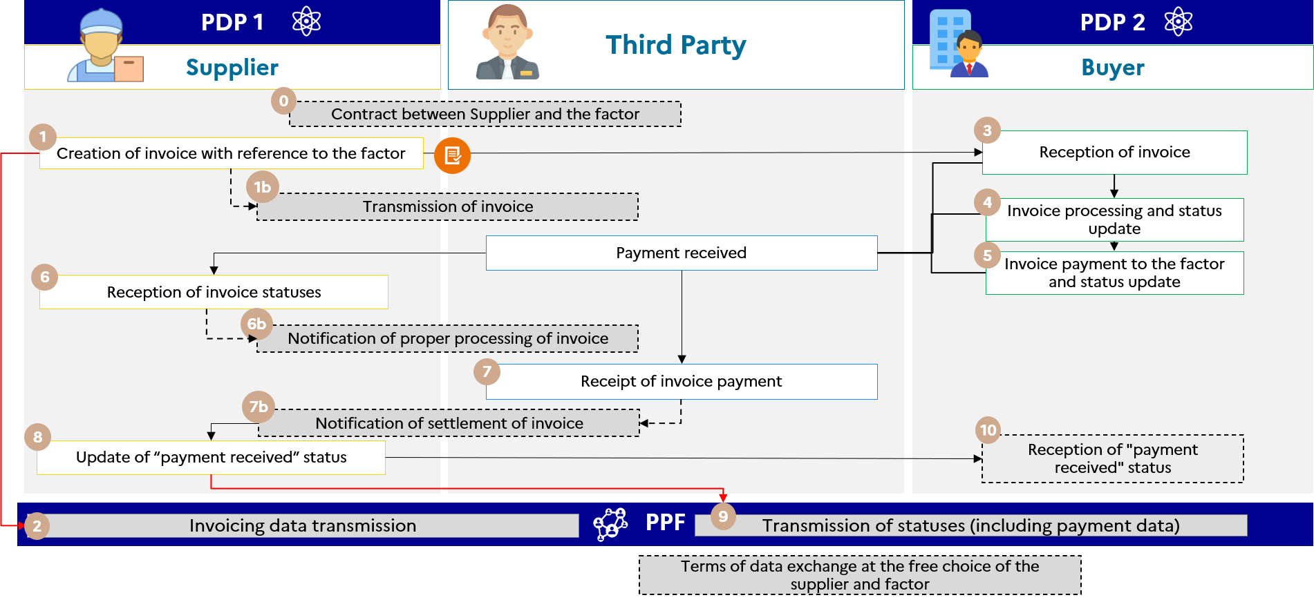

Figure 7 : Invoice to be paid to a third party designated at the time of invoicing (Option 1)

The steps in case no. 8-1 are :

|  |  |  |  |
| --- | --- | --- | --- |
| **Step** | **Step name** | **Party responsible** | **Description** |
| 1 | Creation of invoice with reference to the factor | Supplier | The factor is known at the time of creating the invoice. When sending an invoice flow, use the BG-10 "BENEFICIARY" block to identify the factor and the BG-17 "TRANSFER" block for the elements to pay the factor in the case of the transfer. The invoice type in BT-3 must be set to 393 (Factored invoice). A flow 1 is sent by the supplier’s PDP1 to the public invoicing portal in parallel with flow 2 |
| 2 | Reception of flow 1 | public invoicing portal |
| 3 | Reception of invoice | Buyer | The buyer’s PDP 2 makes the invoice available to the buyer. The buyer processes the invoice in accordance with the life-cycle procedures up to the optional "payment sent" status. A life-cycle flow is sent to the supplier’s PDP. |
| 4 | Invoice processing and status updated before “Payment sent” | Buyer |
| 5 | Invoice payment to the factor and transmission of the status | Buyer |
| 6 | Reception of invoice status | Supplier | The life-cycle flow sent by the buyer's PDP 2 is received by the supplier's PDP 1. |
| 7 | Receipt of invoice payment | Third Party | The third-party factor records receipt of payment of the invoice. The transmission of this information to the public invoicing portal is based on the commercial offer of the platforms. |
| 8 | Updating the "payment received" status and transmission of payment data | Supplier | The supplier updates the status to “payment received” on behalf of the third-party factor through its PDP. The supplier registered private platform transmits the e-reporting flow of payment data to the public invoicing portal |
| 9 | Reception of payment data e-reporting flow | public invoicing portal | The public invoicing portal receives the flow of the payment data for the payment sent by the supplier |
| 10 | Reception of “payment received” status | Buyer | The supplier's PDP 1 can send a life-cycle flow to the buyer's PDP 2 if its commercial offer allows it. |

Option 8-2 can be described as follows :

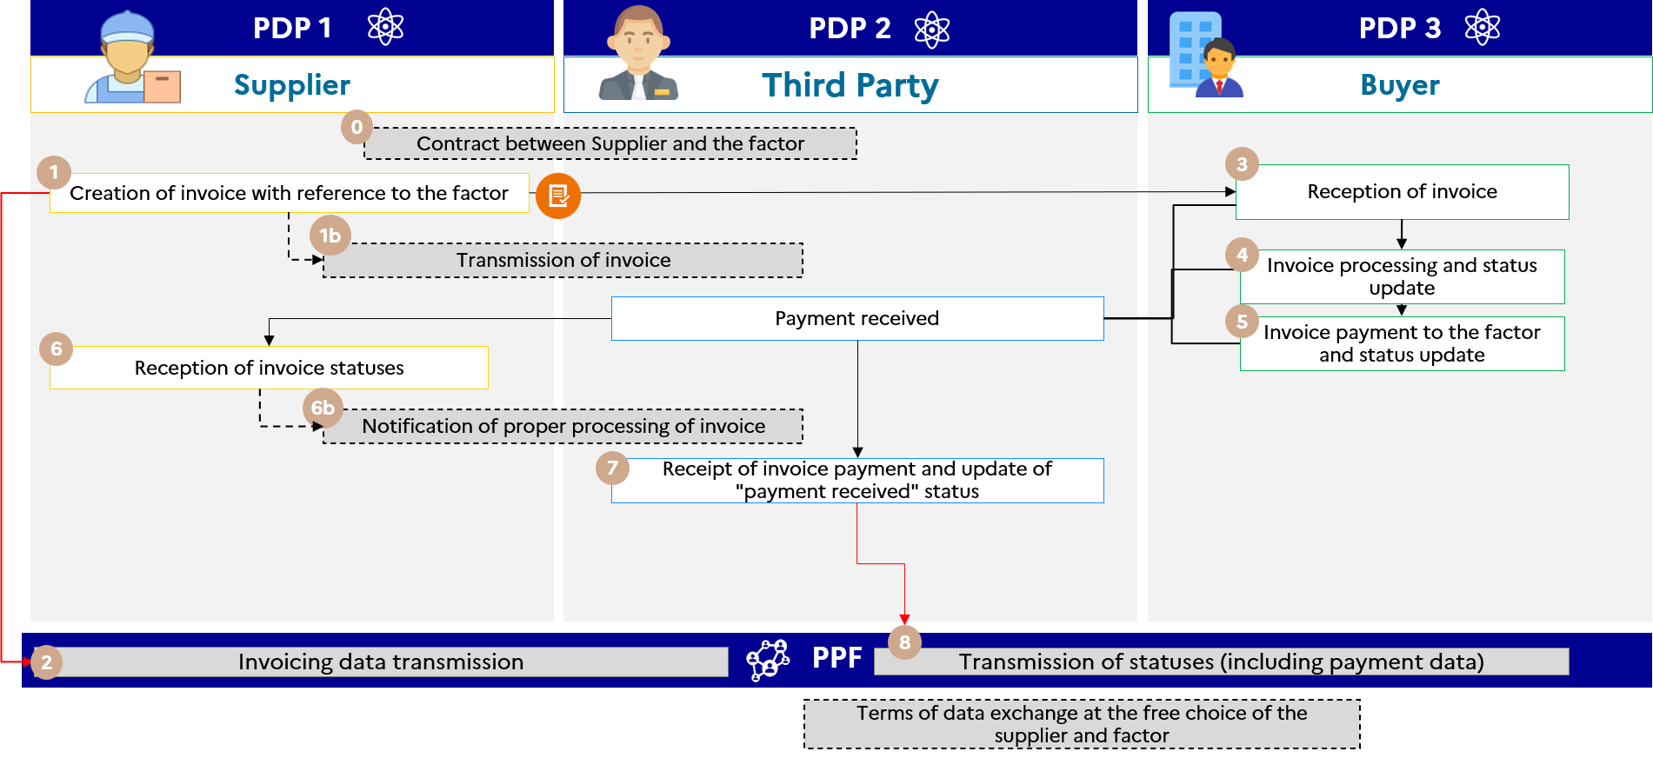

Figure 8 : Invoice to be paid to a third party designated at the time of invoicing (Option 2)

The steps in case no. 8-2 are :

|  |  |  |  |
| --- | --- | --- | --- |
| **Step** | **Step name** | **Party responsible** | **Description** |
| 1 | Creation of invoice with reference to the factor | Supplier | The factor is known at the time of creating the invoice. When sending a flow, use the BG-10 "BENEFICIARY" block to identify the factor and the BG-17 "TRANSFER" block for the elements that make it possible to pay the factor in the case of the transfer. The invoice type in BT-3 must be set to 393 (Factoring invoice). A flow 1 is sent by the supplier's PDP1 to the public invoicing portal in parallel with flow 2 |
| 2 | Reception of flow 1 | public invoicing portal |
| 3 | Reception of invoice | Buyer | The buyer’s PDP 3 makes the invoice available to the buyer. The buyer processes the invoice in accordance with the life-cycle procedures up to the optional "payment sent" status. A life-cycle flow is sent to the supplier’s registered private platform. |
| 4 | Invoice processing and status updated before “Payment sent” | Buyer |
| 5 | Invoice payment to the factor and transmission of the status | Buyer |
| 6 | Reception of invoice status | Supplier | The life-cycle flow sent by the buyer’s PDP 3 is received by the supplier’s PDP 1. |
| 7 | Receipt of invoice payment | Third Party | The third-party factor records receipt of payment of the invoice. |
| 8 | Reception of payment data e-reporting flow | Third Party | The third-party factor’s PDP 2 transmits the payment e-reporting flow to the public invoicing portal.  **/!\** : in legal terms, the obligation to transmit the payment data lies with the supplier. |

More generally, in case 8, the services offered by the public invoicing portal are :

* If the buyer and the third party are connected to the public invoicing portal, the third party will be able to access and modify the invoice and its life cycle
* If the supplier and the third party are connected to the public invoicing portal, the third party will be able to access and modify the invoice and its life cycle
* Parties connected to the public invoicing portal will be notified if the invoice status changes.

#### Case no. 9 : Invoice to be paid to a third party known at the time of invoicing, who also manages the order/receipt, or even the invoicing (Distributor / Depositary)

This case is dealt with in the same way as case no. 8. The various roles (ordering, reception, invoicing) can be added to the invoice flow (flow 2) as needed. They do not affect the data to be sent to the tax authority (flow 1). It is up to the registered private platforms to ensure that a party issuing an invoice on behalf of another company has the necessary billing mandate (there is no management of authorisations and billing mandates in the directory).

Reference can be made to the diagram for case No. 8 "Invoice payable to a Third Party designated at the time of invoicing (factoring, cash pooling)".

#### Case no. 10 : Invoice payable to a third party unknown at the time of invoicing (subrogation by a factor not known at the time of invoicing)

The invoice is payable to a third party, not known to the public invoicing portal at the time of invoicing (factor unknown). A contract must be drawn up between the supplier and the third party before it can be reported to the buyer. Receipt of invoice payment is carried out by the third party. The supplier is responsible for updating the receipt of payment status and forwarding the payment data to the public invoicing portal.

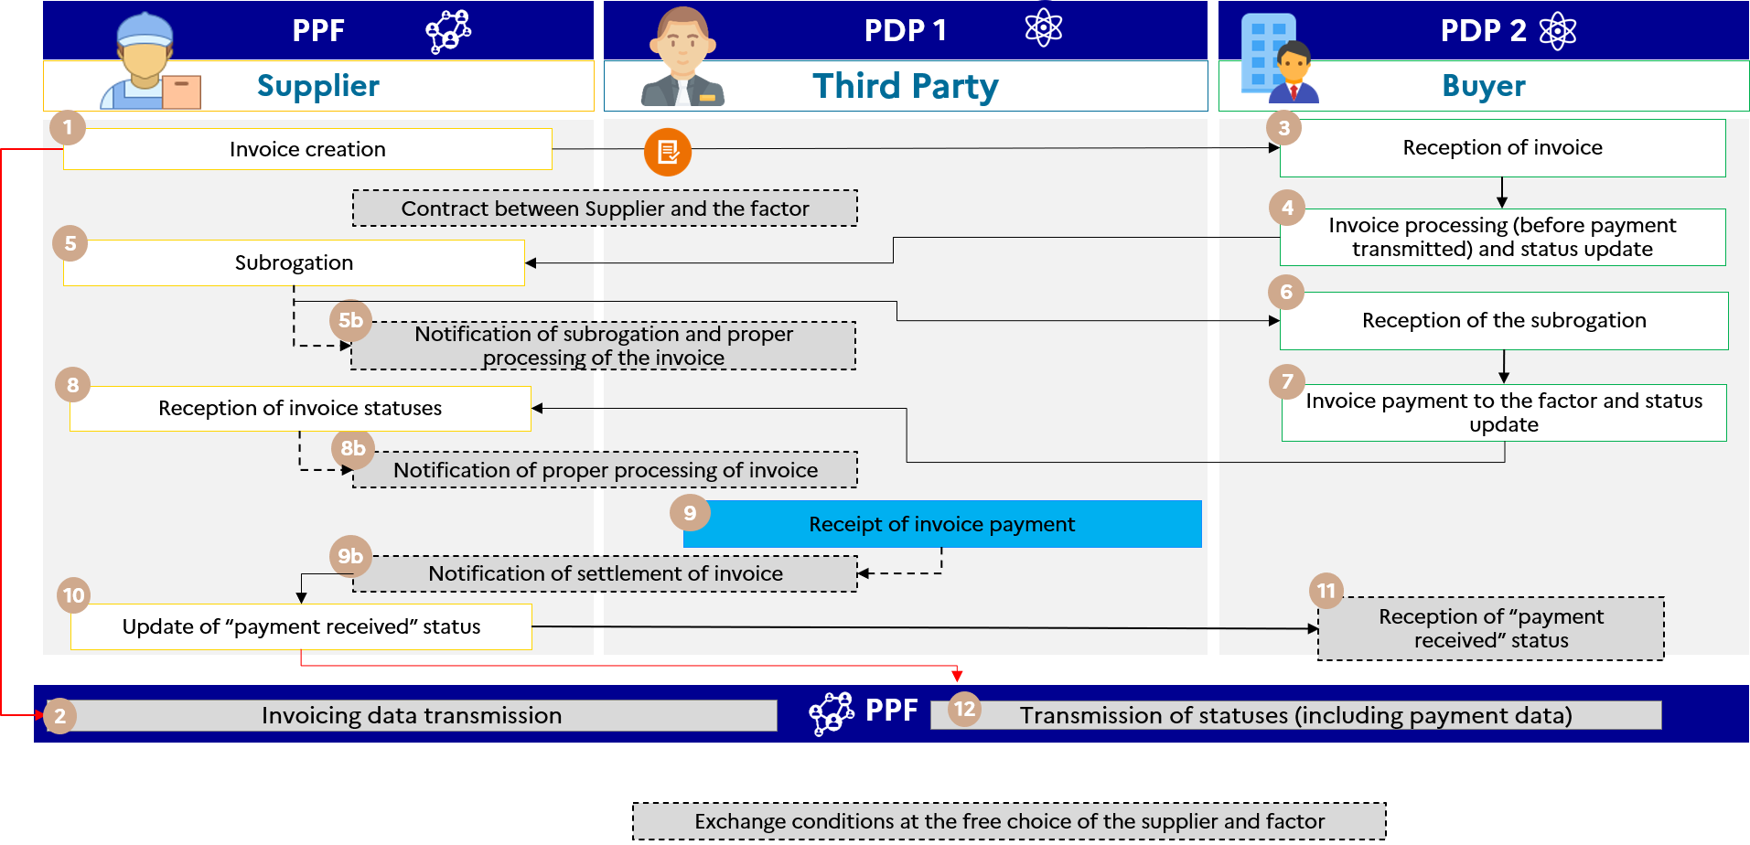

Figure 9 : Invoice payable to a third party unknown at the time of invoicing

The specifics of the associated life cycle or process are :

* Transmission of flow 1 by the supplier platform (public invoicing portal in the example)
* For the transmission of the payment data e-reporting flow, two options are possible (depending on the commercial agreements between the supplier and the factor) :
  + Option 1 : the **supplier** transmits the e-reporting flow of the payment data (see 8-1)
  + Option 2 : the **third-party factor** transmits the e-reporting flow of payment data (see 8-2, registered private platform only)

The services offered by the Public invoicing portal are :

* If the buyer and the third party factor are connected to the public invoicing portal, the third party will be able to read and modify the invoice and its life cycle ;
* If the supplier and the third party are connected to the Public invoicing portal, the third party will be able to access and modify the invoice and its life cycle ;
* Parties connected to the Public invoicing portal will be notified by e-mail if the invoice status changes.

The steps in case no. 10 are :

|  |  |  |  |
| --- | --- | --- | --- |
| **Step** | **Step name** | **Party responsible** | **Description** |
| 1 | Creation of invoice with reference to the factor | Supplier | The factor is unknown at the time of creating the invoice. A flow 1 is sent by the supplier platform (public invoicing portal in the example). |
| 2 | Reception of flow 1 | Public invoicing portal |
| 3 | Reception of invoice | Buyer | The buyer’s PDP 2 makes the invoice available to the buyer. The buyer processes the invoice in accordance with the life-cycle procedures before the optional "payment sent" status. |
| 4 | Invoice processing and status updated before “Payment sent” |
| 5 | Subrogation | Supplier | Subrogation information will be transmitted to the recipient via a life cycle (flow 6).  NB : The procedures for processing the subrogation from the public invoicing portal are detailed in the chapter *Life Cycle* "*Subrogation"* of the External Specifications File - General File. |
| 5b | Notification of subrogation and proper processing of the invoice | Supplier |
| 6 | Reception of the subrogation | Buyer |
| 7 | Invoice payment to the factor and transmission of the status | Buyer | Once the buyer has paid the third party, the third party records receipt of payment. Notification of this action depends on the platforms’ commercial offer. |
| 8 | Receipt of invoice payment | Third Party |
| 8b | Notification of proper processing of invoice | Supplier | The third party updates the receipt status of the invoice through its registered private platform 1. |
| 9 | Update of “payment received” status | Supplier | The supplier updates the "payment received" status on behalf of the third-party factor through its platform (public invoicing portal in the example). The supplier platform therefore sends the e-reporting payment flow for declaration to the tax authority. Updating the "payment received" status may be performed by the factor if the supplier so wishes. |
| 9b | Notification of settlement of invoice | Supplier |
| 10 | Reception of payment data e-reporting flow | Public invoicing portal |
| 11 | Reception of “payment received” status | Buyer | Depending on the commercial offer of the registered private platform 2, the customer can be informed of the "payment received" status. |

### Case no. 11 : Invoice with invoice (INVOICEE) other than the buyer (BUYER)

This management case covers the business case of a third party (e.g. a management company) who manages the invoices and accounts of a company. The invoice is in the name of the taxable buyer (whose transactions are subject to electronic invoicing) but sent to a third party.

The public invoicing portal will ensure that these invoices are addressed to third parties subject to the tax and therefore present in the directory.

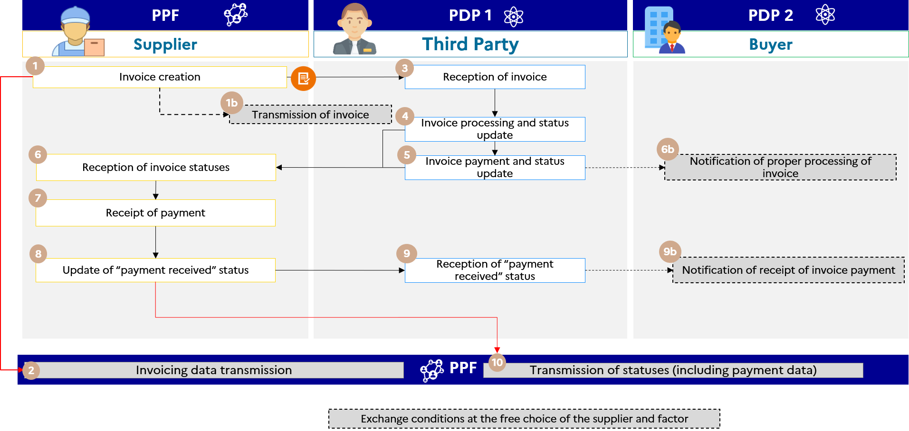

Figure 10 : Invoice with INVOICEE) other than the BUYER

The data specifics and associated management rules are :

* The buyer (the establishment) must be entered in the BUYER’s block (BG-7)
* The entity to which the invoice is sent must be indicated in a new block “INVOICEE” (EXT-FR-FE-BG-04). If the entity to which the invoice is sent also has to pay the invoice, then this entity can also be entered in the "PAYER" block (EXT-FR-FE-BG-02)
* The invoice will then be sent to this entity/the entity to which this invoice is to be addressed to “INVOICEE”. Below are the ways to access/update the invoice :
  + The buyer will be able to access the invoice and update its status on the public invoicing portal if the supplier or the invoicee (the company head office in our example) is connected to the public invoicing portal (Circuit A, B1)
  + If the invoicee is connected to the public invoicing portal and the supplier/buyer to a separate registered private platform (circuit C), the buyer will not have access to the invoice.

The specifics of the life cycle or process are :

* Transmission of Flow 1 and Payment Data e-reporting by supplier registered private platform

The services offered by the Public invoicing portal are :

* If the third party and the buyer are connected to the Public invoicing portal, the third party will have read-access to the invoice and its life cycle ;
* If the supplier and the buyer are connected to the Public invoicing portal, the third party will have read-access to the invoice and its life cycle ;
* Parties who are connected to the public invoicing portal will be notified via the issue of a life cycle flow if the invoice status changes.

The steps in case no. 11 are :

|  |  |  |  |
| --- | --- | --- | --- |
| **Step** | **Step name** | **Party responsible** | **Description** |
| 1 | Invoice creation | Supplier | The invoice is generated by the supplier and is sent by its platform (public invoicing portal in the example) to the third-party platform (registered private platform 1) designated in the INVOICEE block. A parallel flow 1 is sent by the supplier platform for declaration to the tax authority. |
| 2 | Reception of flow 1 | Public invoicing portal |
| 3 | Reception of invoice | Third Party | The third party's registered private platform 1 makes the invoice available to the third party. The third party processes the invoice in accordance with the life-cycle procedures before the optional "payment sent" status. When payment is made by the third party to whom the invoice is sent, that third party can also be entered in the PAYER block (EXT-FR-FE-BG-02). The third party then pays the invoice and updates the optional “payment sent” status. |
| 4 | Invoice processing and status updated before “Payment sent” |
| 5 | Invoice payment to the factor and transmission of the status |
| 6 | Reception of invoice statuses | Supplier | The supplier platform (public invoicing portal in the example) provides the invoice statuses. |
| 6b | Notification of proper processing of invoice | Buyer | The buyer receives notification of proper processing and payment of the invoice. |
| 7 | Receipt of invoice payment | Supplier | Once the buyer has paid the third-party invoice, the third party records receipt of payment. Information on this action is reflected in the "payment received" status, which will be updated once the supplier has been paid. |
| 8 | Update of “payment received” status | When paid, the supplier updates the "payment received" status on behalf of the third party through its platform (public invoicing portal in the example). |
| 9 | Reception of “payment received” status | Third Party | The third party's PDP 1 makes the "payment received" status available to the third party of the invoice. |
| 9b | Notification of settlement of invoice | Buyer | The buyer receives notification of receipt of invoice payment |
| 10 | Reception of payment data e-reporting flow | Public invoicing portal | The supplier platform (public invoicing portal in the example) then sends the payment e-reporting flow for declaration to the tax authority. |

### Case 12 : Transparent intermediary as invoice manager for the buyer principal

For VAT purposes, the transparent intermediary acts as a broker between two persons in the negotiation of contracts and the financial solicitation of suppliers or clients.

From the VAT perspective, the transparent intermediary is considered to be acting on behalf of and in the name of another person.

He or she appears as the representative of the principal in its relations with co-contracting third parties (BOI-TVA-CHAMP-10-10-40-40, § 20).

In practice, the principal may be the supplier or the client.

The invoicing scheme for transparent intermediaries requires at least two invoices :

* **An invoice created by the intermediary regarding the provision of its service (PS)**

The intervention operations for this type of intermediary are considered as supplies of services, regardless of the service to which the intervention is subject (see BOI-TVA-CHAMP-10-10-40-40, §40). Therefore, intervention services follow their own VAT regime and must be invoiced.

* **An invoice created by the supplier/provider and made in the name of the customer.**

As a matter of principle, the supplier makes the main invoice in the name of the recipient of the goods or services.

As soon as the main invoice and the invoice for mediation services are issued between two taxable entities established in France, they enter the domain of electronic invoicing and pass between the supplier’s/provider’s platform and the recipient’s platform :

* The main invoice is sent directly from the issuer to the recipient via the selected platforms,
* The invoicing data are transmitted via the platform of the invoice issuer.

**If the transparent intermediary also acts as the invoice manager of the buyer principal, i.e. in reception of invoices on behalf of the customer**, so that the intermediary receives invoices directly on its behalf, the “INVOICEE” block will allow a third party other than the buyer client to be indicated on the invoice, as applicable. If the principal is on the public invoicing portal, it will have access to the invoice (except for EDI access).

In this case, if an invoicing report or summary invoice is sent to the buyer via an intermediary, these documents will be excluded from electronic invoicing and must be sent off the invoicing circuit of the public invoicing portal.

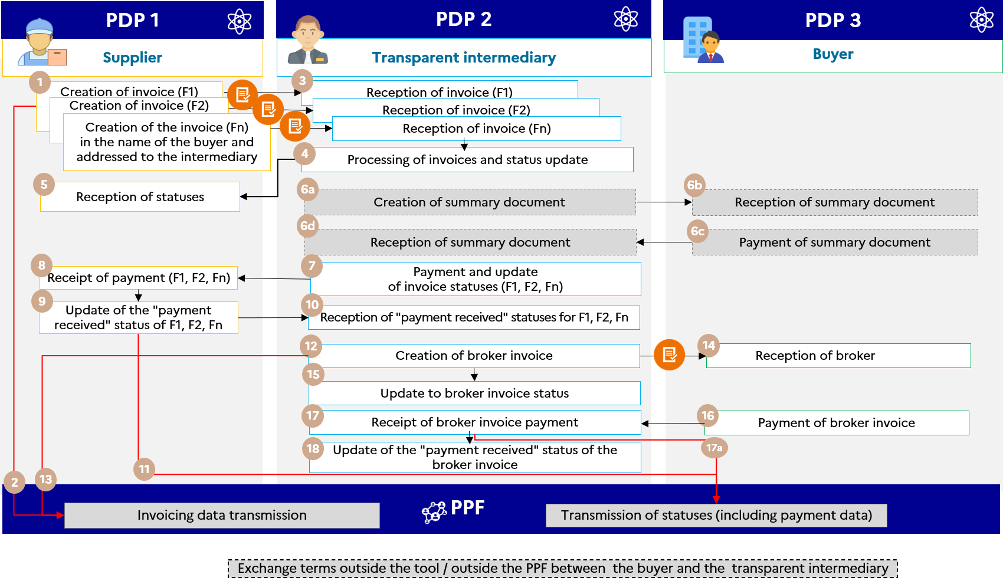

Figure 11 : Transparent intermediary

### Cases Nos. 13 and 14 : Case of subcontracting and co-contracting (B2B/B2C)

Liminary : This section deals only with cases of subcontracting and co-contracting that do not fall under the "Work Invoice" feature provided in B2G on Chorus Pro.

At this stage, private works contracts (B2B) must give rise to a standard electronic invoice through platforms (public invoicing portal or registered private platform). Thus, only the work invoice with all the mandatory remarks has to be submitted, with the draft accounts to circulate outside the "electronic invoicing" tool.

#### Overview of procedures for subcontracting

In the case of B2B subcontracting, two separate invoices must be processed in electronic invoicing :

* The subcontractor sends an invoice (F1) to the principal (supplier). If the transaction is eligible for reverse charge VAT, the subcontractor’s invoice must include the remark “reverse charge VAT by the customer” ; otherwise it mentions the amount of VAT due on its service.
* The principal/account holder sends the buyer an invoice (F2) for the total amount of the services and/or goods. Invoice F2 shows the VAT due on the total amount excluding VAT (contract holder’s service + subcontractor’s service).

No special procedures are required for the processing of these invoices ; they are treated as standard invoices.

In the case of B2G subcontracting, regardless of the validation issued by the owner, the subcontractor's invoice is always sent to the public recipient.

However, special payment terms may apply.

These are sanctioned under the Public Procurement Code (Article L.2193-10) and Act 75-1334 of 31 December 1975 (Title II) on direct payment in respect of subcontracting. The aforementioned legislation applies to public contracts and to contracts awarded by public enterprises which are not buyers subject to the Public Procurement Code. Where the subcontractor of a contract holder is entitled to direct payment, it may be paid directly by the public entity for the part of the contract it carries out. Nevertheless, validation by the contract owner within 15 days is still necessary. Otherwise, this validation is tacit (Articles R.2193-12 and R.2193-13 of the public procurement code).

In other subcontracting agreements, especially in the context of private contracts, the buyer may pay the subcontractor directly by assignment of the rights of payment of the contractor, as provided for in Article 14 of the aforementioned Act. A validation of the owner is also planned ; it cannot be tacit.

In case of direct payment of the subcontractor in the framework of public procurement, an invoicing framework specific to public contracts will be provided : Box S3 (Submission of a subcontracting service invoice with direct payment).

In case of delegation of payment in other cases of subcontracting, the invoicing framework to be mentioned is the code “S5” (Submission by a subcontractor of a service invoice). However, the "EXT-FR-FE-BG-02 - PAYER OF THE INVOICE" block may be used and completed in invoice F1 (between the subcontractor and the principal) to indicate payment by the buyer (final customer - contracting authority) of F2 (see case 3 of the external specifications).

#### Case 13 : Invoice to be paid by a third party (in case of subcontracting with direct payment or payment delegation)

Management case No. 13 covers the business case of a subcontractor who, in the context of a contract, transmits an invoice to the supplier but with a direct payment by the buyer as defined in the Public Procurement Code or by delegation in the context of private contracts.

##### Case of subcontracting by delegation in B2B

The modelling for B2B subcontracting invoices is different from B2G because the recipient does not receive the subcontractor invoice. Therefore, the issue of 2 invoices needs to be distinguished :

* A first invoice (F1) from the subcontractor for the owner
* A second invoice (F2) from the owner to the buyer

The data specifics and associated management rules are :

* BG-4 : subcontractor
* BG-7 : supplier/owner
* EXT-FR-FE-BG-02 (PAYER OF THE INVOICE) : buyer
* Total amount of the invoice (BT-112) : subcontractor service amount
* BT-23 : S5 (Submission of an invoice for services by a subcontractor)

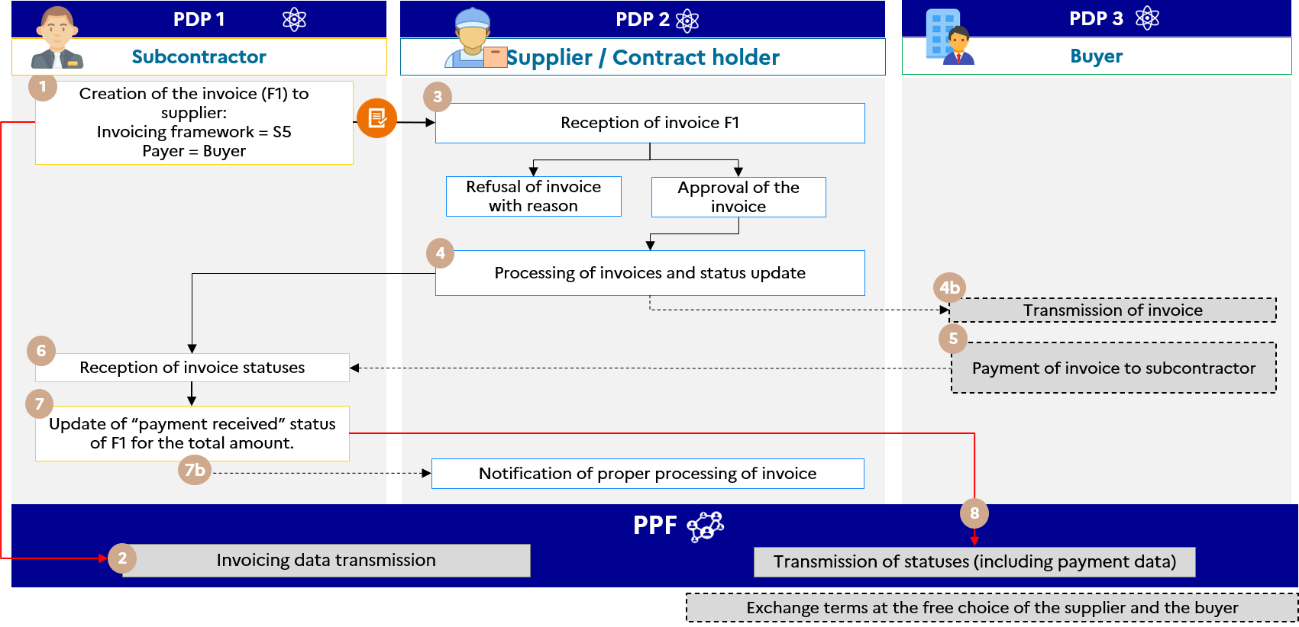

Figure 12 : Invoice (F1) to be paid by a third party (case of subcontracting by delegation in B2B)

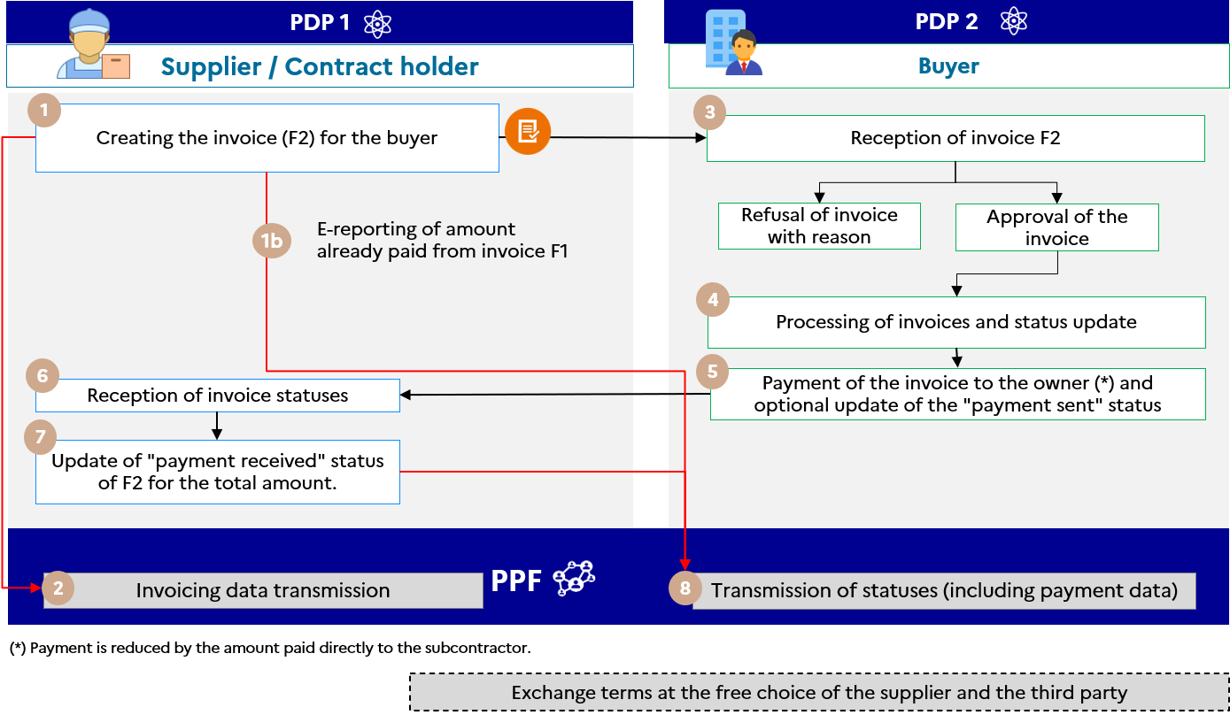

Figure 13 : Invoice (F2) to be paid by a third party (case of subcontracting by delegation in B2B)

##### Case of subcontracting with direct payment in B2G

In the case of subcontracting in the context of public contracts (excluding works invoice functionalities and bills for legal costs), the owner "endorses" the subcontractor's invoice, which is in all cases sent to the buyer (public recipient).

The data specifics and associated management rules are :

* BG-4 : subcontractor
* BG-7 : buyer (public recipient)
* EXT-FR-FE-BG-03 (SELLER AGENT) : supplier/owner
* Total amount of the invoice (BT-112) : subcontractor service amount
* BT-23 : S3 (Submission of an invoice for subcontracting services with direct payment)

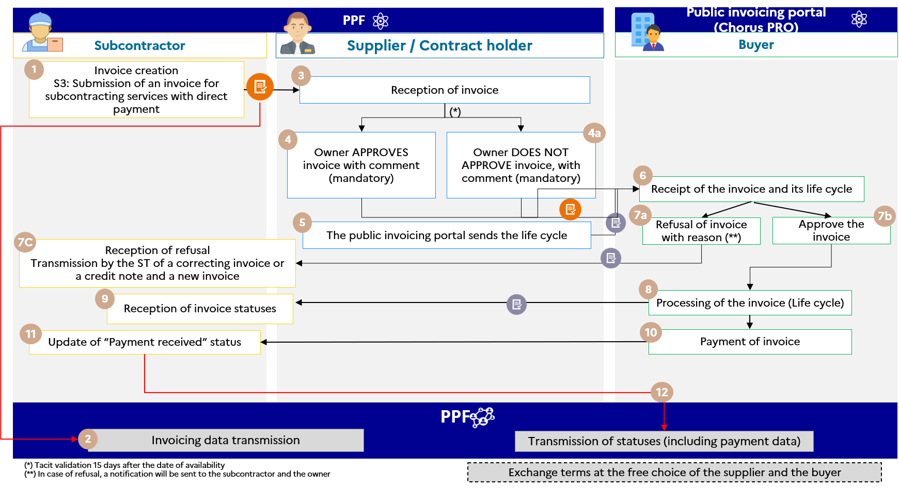

Figure 14 : Invoice payable by a third party (case of subcontracting with direct payment in B2G)

The steps in the management case are :

|  |  |  |  |
| --- | --- | --- | --- |
| **Step** | **Step name** | **Party responsible** | **Description** |
| 1 | Creation of the invoice for the owner | Subcontractor | The subcontractor will forward an invoice covering his service to the supplier/owner. |
| 2 | Receipt of invoicing data | public invoicing portal | A parallel flow declaring invoicing data is sent by the public invoicing portal, which receives the information |
| 3-4-4b | Reception of invoice | Owner | The invoice will be made available to the owner  Several possible case scenarios :   1. The owner VALIDATES the invoice with a mandatory comment that makes it possible to add information for the public recipient 2. The owner DOES NOT VALIDATE the invoice with a mandatory comment, which makes it possible to add information for the public recipient 3. The invoice will not be processed by the owner within 15 days of the invoice being made available. In this case the invoice will be tacitly validated with a generic comment in order to warn the public recipient of this tacit validation   In all cases, the public invoicing portal forwards the invoice to the public invoicing portal (Chorus PRO). |
| 5 | Life cycle transmission | public invoicing portal | The public invoicing portal transmits a life cycle flow to the public invoicing portal (Chorus PRO). |
| 6 | Reception of invoice | Buyer | The public invoicing portal (Chorus PRO) makes the invoice available to the public recipient |
| 7A | Refusal of the invoice | Buyer | The public recipient can also refuse the invoice (with a mandatory comment).  In this case, the public invoicing portal (Chorus PRO) transmits a life cycle flow to the public invoicing portal to make it available for the subcontractor and the owner of the refusal.  These parties will also be notified of the refusal. |
| 7B | Approval of the invoice | Buyer | The public recipient approves the invoice. |
| 7C | Reception of refusal | Subcontractor  Owner | The 2 parties are informed of the refusal and the subcontractor can return a credit note and a new invoice or a correcting invoice. |
| 8-9 | Invoice status processing | Buyer | The buyer can change the invoice statuses that will be sent to the public invoicing portal in order to be made available for the 2 parties on the invoice |
| 10 | Payment of invoice | Buyer | The public recipient will pay the invoice and attach the status of "payment sent" in order to inform the 2 parties on the invoice |
| 11 | Receipt of invoice payment | Subcontractor | The subcontractor changes the status of the invoice : "payment received" |
| 12 | Reporting of payment data | Public invoicing portal | The public invoicing portal generates payment data to make it available for the tax authority |

**Note that :** The subcontractor and the owner must have an account on the public invoicing portal.

#### Case 14 : Invoice to be paid by a third party (co-contracting)

##### Case of B2B co-contracting

B2B co-contracting management is different from B2G. There are 2 invoices to be produced :

1. The invoice from the contractor to the representative ;
2. Invoice from representative to buyer.

The data specifics and associated management rules are :

|  |  |
| --- | --- |
| Invoice F1 | Invoice F2 |
| * Invoicing framework : S6 (Submission of an invoice for services by a co-contractor) * Supplier (BG-4) : co-contractor * Seller Agent (EXT-FR-FE-BG-03) : representative * Addressed to (EXT-FR-FE-BG-04) : representative * Buyer (BG-7) : Buyer | * Invoicing framework : S6 (Submission of an invoice for services by a co-contractor) * Supplier (BG-4) : representative * Seller Agent (EXT-FR-FE-BG-03) : representative * Buyer (BG-7) : Buyer * Buyer Agent (EXT-FR-FE-BG-01) : project manager |

The buyer receives invoices only via the representative of the contract.

When the buyer receives the invoice from the representative, he pays the 2 invoices.

The services offered by the public invoicing portal are :

* If the third party and the buyer are connected to the public invoicing portal, the third party will have read-access to the invoice and its life cycle ;
* If the supplier and the buyer are connected to the public invoicing portal, the third party will have read-access to the invoice and its life cycle ;
* Parties who are connected to the public invoicing portal will be notified via the issue of a life cycle flow if the invoice status changes.

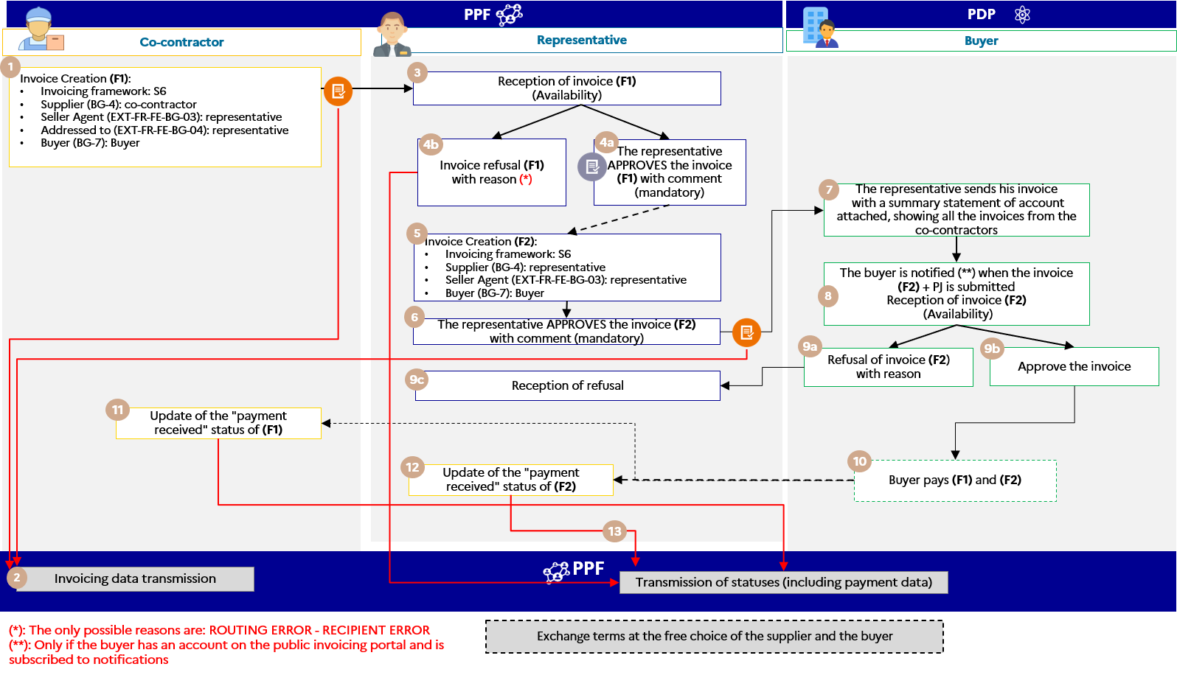

Figure 15 : Invoice to be paid by a third party (B2B co-contracting)

The steps in the management case are :

|  |  |  |  |
| --- | --- | --- | --- |
| **Step** | **Step name** | **Party responsible** | **Description** |
| 1 | Creating the invoice (F1) for the representative | Co-contractor | The co-contractor will forward an invoice for its service to the representative.  Since the buyer receives the invoice by default, the INVOICEE block (EXT-FR-FE-BG-04) is used to indicate the representative. He will be the last recipient of the invoice |
| 2 | Receipt of invoicing data | Public invoicing portal | A parallel flow declaring invoicing data is sent by the public invoicing portal, which receives the information |
| 3-4a-4b | Reception of invoice | Representative | The invoice (F1) is made available to the representative.  Several possible case scenarios :   1. The representative can only refuse the invoice for one of the 2 possible reasons for refusal. The co-contractor will be notified of this refusal 2. The representative VALIDATES the invoice with a comment that makes it possible to add information for the buyer |
| 5-6 | Creating the invoice (F2) for the buyer | Representative | The representative sends an invoice for its service to the buyer.  For this invoice (F2), the representative will have to self-validate (because the same invoicing framework is used, which requires a validator).  **/!\ : As part of the work contracts, the representative will be able to attach the draft summary account to the invoice.** |
| 7-8 | Reception of invoice | Buyer | The buyer receives the invoice, which may attach the draft summary statement containing all the co-contractors' invoices.  With this document, he knows the amounts to be paid, to which suppliers and with which bank details. |
| 9a-9b | Reception of invoice | Buyer | The invoice (F2) is made available to the buyer.  Several possible case scenarios :   1. The buyer may refuse the invoice with a reason for refusal. The representative will be notified of this refusal by the public invoicing portal if it has a user account and subscribes to notifications. 2. The buyer approves the invoice. |
| 9c | Refusal of the invoice | Buyer | In case of refusal by the buyer, a life cycle flow is transmitted to the public invoicing portal to make the refusal available for the representative.  The refusal will also be notified. |
| 10 | Payment of invoice | Buyer | The buyer pays the invoice (F1) and (F2). |
| 11 | Receipt of invoice payment | co-contractor | The co-contractor changes the "payment received" status of the invoice. |
| 12 | Receipt of invoice payment | Representative | The representative changes the "payment received" status of the invoice. |
| 13 | Reporting of payment data | Public invoicing portal | The public invoicing portal generates the payment data to be made available to the tax authority for invoices (F1) and (F2). |

##### Case of B2G co-contracting

This case deals with co-contracting outside works contracts.

In B2G, a single invoice is sent by the co-contractor which, once approved by the authorised representative, is made available to the public recipient.

In the case of a transfer of the invoice from the co-contractor to the representative, the specific data and associated management rules will be :

* BG-4 : co-contractor
* BG-7 : the public recipient
* EXT-FR-FE-BG-03 : the seller agent block is used to indicate the representative
* Total amount of the invoice (BT-112) : Amount of co-contractor's services
* BT-23 : S6 (Submission of an invoice for services by a co-contractor)

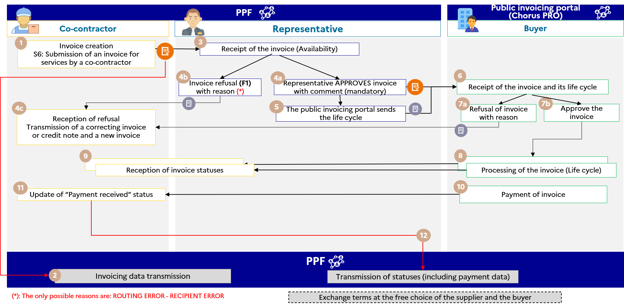

Figure 16 : Invoice to be paid by a third party (B2G co-contracting)

The steps in the management case are :

|  |  |  |  |
| --- | --- | --- | --- |
| **Step** | **Step name** | **Party responsible** | **Description** |
| 1 | Creation of the invoice for the representative | Co-contractor | The co-contractor will forward an invoice for his service to the representative. |
| 2 | Receipt of invoicing data | Public invoicing portal | A parallel flow declaring invoicing data is sent by the public invoicing portal, which receives the information. |
| 3-4A-4B | Reception of invoice | Representative | The invoice is made available to the representative  Several possible case scenarios :   1. The representative can only refuse the invoice for one of the 2 possible reasons for refusal. The co-contractor will be notified of this refusal 2. The representative endorses the invoice with a comment that makes it possible to add information for the public recipient.   Invoice is sent to the public invoicing portal (Chorus PRO) |
| 4C | Receipt of the refusal of the invoice | Co-contractor | The co-contractor may consult the reason for refusal and the associated comment. It can return a credit note and a new invoice or a correcting invoice |
| 5 | Life cycle transmission | Public invoicing portal | The public invoicing portal passes a life cycle flow to the public invoicing portal (Chorus PRO) |
| 6 | Reception of invoice | Buyer | Chorus PRO makes the invoice available to the public recipient |
| 7A | Refusal of the invoice | Buyer | The public recipient can also refuse the invoice (with a mandatory comment).  In this case, Chorus PRO transmits a life cycle flow of the refusal to the public invoicing portal top make it available for the co-contractor and the representative.  These parties will also be notified of the refusal |
| 7B | Approval of the invoice | Buyer | The public recipient approves the invoice |
| 4C | Reception of refusal | Co-contractor  Representative | The 2 parties are informed of the refusal and the subcontractor can return a credit note and a new invoice or a correcting invoice |
| 8-9 | Invoice status processing | Buyer | The buyer can change the invoice statuses that will be sent to the public invoicing portal in order to be made available to the 2 parties on the invoice. |
| 10 | Payment of invoice | Buyer | The public recipient will pay the invoice and attach the status of "payment sent" in order to inform the 2 parties on the invoice |
| 11 | Receipt of invoice payment | Co-contractor | The co-contractor changes the status of the invoice : "payment received" |
| 12 | Reporting of payment data | Public invoicing portal | The public invoicing portal generates payment data to make it available for the tax authority |

**Note that :** The co-contractor and representative must have an account on the public invoicing portal.

### Case 15 : Sales invoice following order/payment of a third party on behalf of the BUYER

Management case no. 15 covers the business case of an order by a third party on behalf of the buyer and the transmission of a sales invoice from the supplier to the buyer with identification of the third party.

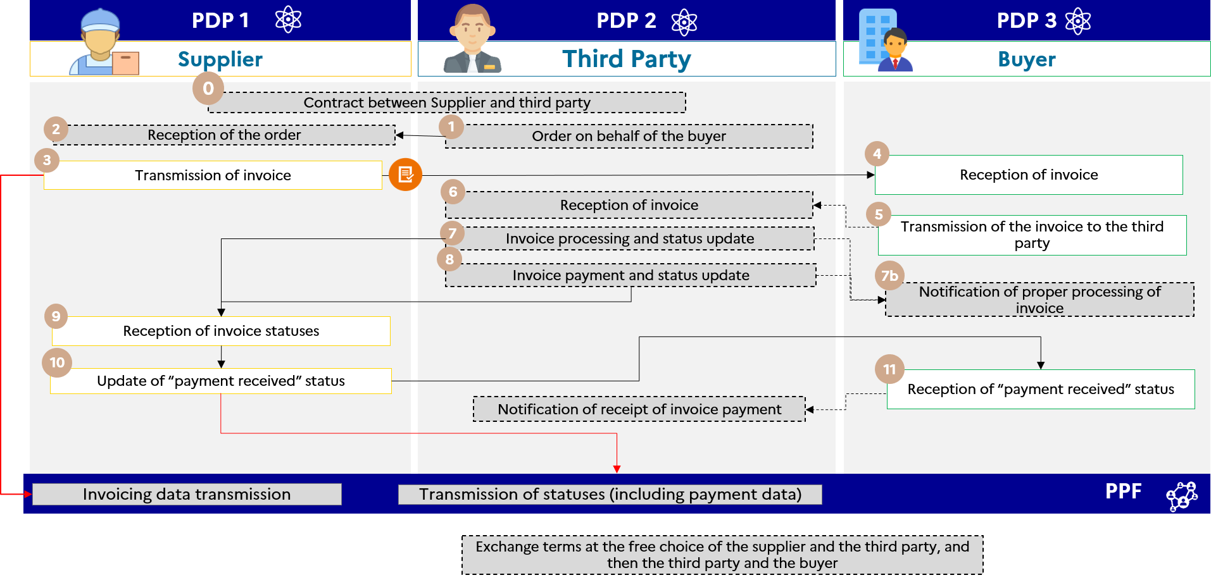

Figure 17 : Sales invoice following an order / payment from a third party on behalf of the buyer (media purchase, consultancy fees)

The supplier’s registered private platform 1 transmits a flow 2 to the buyer’s registered private platform. Given that it is the third party that pays the invoice, the specifics of the data and associated management rules are :

* BG-4 : Supplier
* BG-7 : Buyer
* EXT-FR-FE-BG-02 (INVOICE PAYER) : third party
* EXT-FR-FE-BG-01 (BUYER'S AGENT) : third parties (in some cases)

The specifics of the associated life cycle or process are :

* Transmission of Flow 1 and e-reporting of payment data through the third-party platform

The services offered by the Public invoicing portal are :

* If the the buyer and third party are connected to the Public invoicing portal, the third party will have read-access to the invoice and its life cycle ;
* If the supplier and the buyer are connected to the Public invoicing portal, the buyer will have read-access to the invoice and its life cycle ;
* Parties who are connected to the public invoicing portal will be notified via the issue of a life cycle flow if the invoice status changes.

The steps in case no. 15 are :

|  |  |  |  |
| --- | --- | --- | --- |
| **Step** | **Step name** | **Party responsible** | **Description** |
| 1 | Order on behalf of the buyer | Third Party | The third party will send an order to the supplier on behalf of the buyer (see services offered by the registered private platform) without the use of the Public invoicing portal tool. |
| 2 | Reception of the order | Supplier | The supplier receives the order |
| 3 | Transmission of invoice | Supplier | The supplier’s registered private platform 1 transmits a flow 2 to the buyer’s registered private platform 3 in parallel to the Public invoicing portal (flow 1) for transmission of the invoice data.  Given that it is the third party that pays the invoice, the invoice specifies the following parties :  - BG-4 : Supplier  - BG-7 : Buyer  - EXT-FR-FE-BG-02 (PAYER OF INVOICE) : Third party  - EXT-FR-FE-BG-01 (BUYER'S AGENT) : Third parties (in some cases) |
| 4 | Reception of invoice | Buyer | The buyer’s registered private platform 3 makes the invoice available |
| 5 | Transmission of the invoice to the third party | Buyer | The buyer’s registered private platform 3 forwards the invoice to the third party’s registered private platform 2 |
| 6 | Reception of invoice | Third Party | The third party’s registered private platform 2 makes the invoice available to it. |
| 7 | Invoice processing and status update | Third Party | The third party processes the invoice in accordance with the life-cycle procedures up to optional "payment sent" status. |
| 8 | Invoice payment and status update | Third Party | The third party will make payment of the invoice and update the optional "payment sent" status if it so wishes. |
| 9 | Reception of invoice status | Supplier | The supplier receives the status of the invoice and records receipt by changing the status to “payment received”  The supplier registered private platform transmits the payment data to the Public invoicing portal and at the same time transmits a life cycle of the receipt to the buyer. |
| 10 | Update of “payment received” status |
| 11 | Reception of “payment received” status | Buyer | The buyer’s registered private platform receives the “payment received” invoice status.  The buyer can send a life-cycle flow to inform the third party of receipt of invoice payment by the supplier, if its commercial offer allows it. |

### Case no. 16 : Disbursement invoice for reimbursement of the sales invoice paid by the third party

These invoices are beyond the scope of the e-invoicing reform. Their management is therefore not part of the scope of the public invoicing portal, but can nevertheless be carried out by the registered private platforms as they have defined.

### Case no. 17a : Invoice payable to a third party, payment intermediary (e.g. on Marketplace)

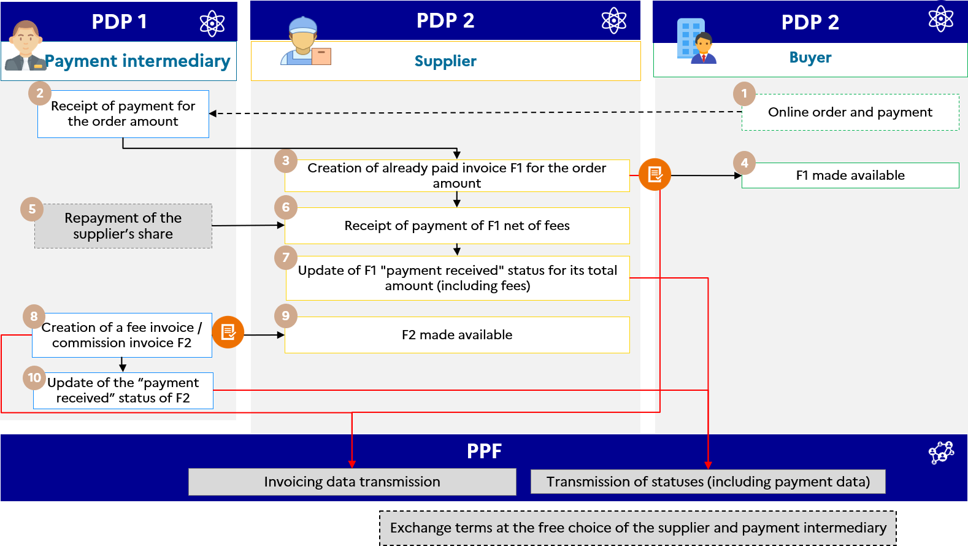

Figure 18 : Invoice payable to a third party, payment intermediary

Legend :

* F1 : The “already paid” invoice issued by the supplier
* F2 : The "already paid" commission/fee invoice issued through the payment intermediary

The data specifics and associated management rules are :

* Invoicing framework “Submission of an invoice already paid”
* Due date is identical to payment date
* Amount paid (BT-113) is equal to the total invoice amount
* Amount payable (BT-115) is equal to 0
* In invoice F2, the third party who is the one who has already paid the invoice (he pays himself) can be indicated in the "PAYER OF THE INVOICE" block (EXT-FR-FE-BG-02)

**F1 : third party = PAYER**

**F2 : third party = SELLER = PAYER**

The specifics of the life cycle or process are :

* Transmission of Flow 1 (F1) and e-reporting via supplier platform
* Transmission of Flow 1 (F2) and e-reporting via the payment intermediary platform

The steps in case no. 17a are :

|  |  |  |  |
| --- | --- | --- | --- |
| **Step** | **Step name** | **Party responsible** | **Description** |
| 1 | Online order and payment | Buyer | The buyer places an order on the Internet and makes the payment. |
| 2 | Receipt of payment for the order amount | Payment intermediary | The intermediary receives payment of the full amount of the order placed by the buyer |
| 3 | Creation of already paid invoice F1 for the order amount | Supplier | The supplier’s PDP 2 transmits invoice F1 (flow 2) to the taxable professional buyer’s PDP 3 which makes it available to the buyer. In parallel, it forwards the invoicing data to the PUBLIC INVOICING PORTAL. |
| 4 | F1 made available | Buyer |
| 5 | Repayment of the supplier’s share | Payment intermediary | The intermediary’s PDP 1 transmits the amount (share) to the supplier’s PDP 2. |
| 6 | Receipt of payment of F1 net of fees | Supplier | When the supplier is paid through the payment intermediary, it updates the “payment received” status of F1 for the total amount.  Step 7 applies only to supply of services, excluding the option to pay VAT on debits. |
| 7 | Update of “payment received” status of F1 for the total amount. | Supplier |
| 8 | Creation of an already paid fee / commission invoice F2 | Payment intermediary | The intermediary’s PDP 1 transmits the already paid fee / commission invoice (F2 – Flow 2) to the supplier and it is made available to the supplier by its PDP. In parallel, the intermediary’s PDP forwards the invoicing data to the PUBLIC INVOICING PORTAL. |
| 9 | F2 made available | Supplier |
| 10 | Update of the “payment received” status of F2 | Payment intermediary | The PDP 1 of the payment intermediary transmits the payment data of the commission/intermediation invoice to the PUBLIC INVOICING PORTAL.  Step 10 applies only to supply of services, excluding the option to pay VAT on debits. |

### Case no. 17b : Invoice payable to a third party, payment intermediary and billing mandate

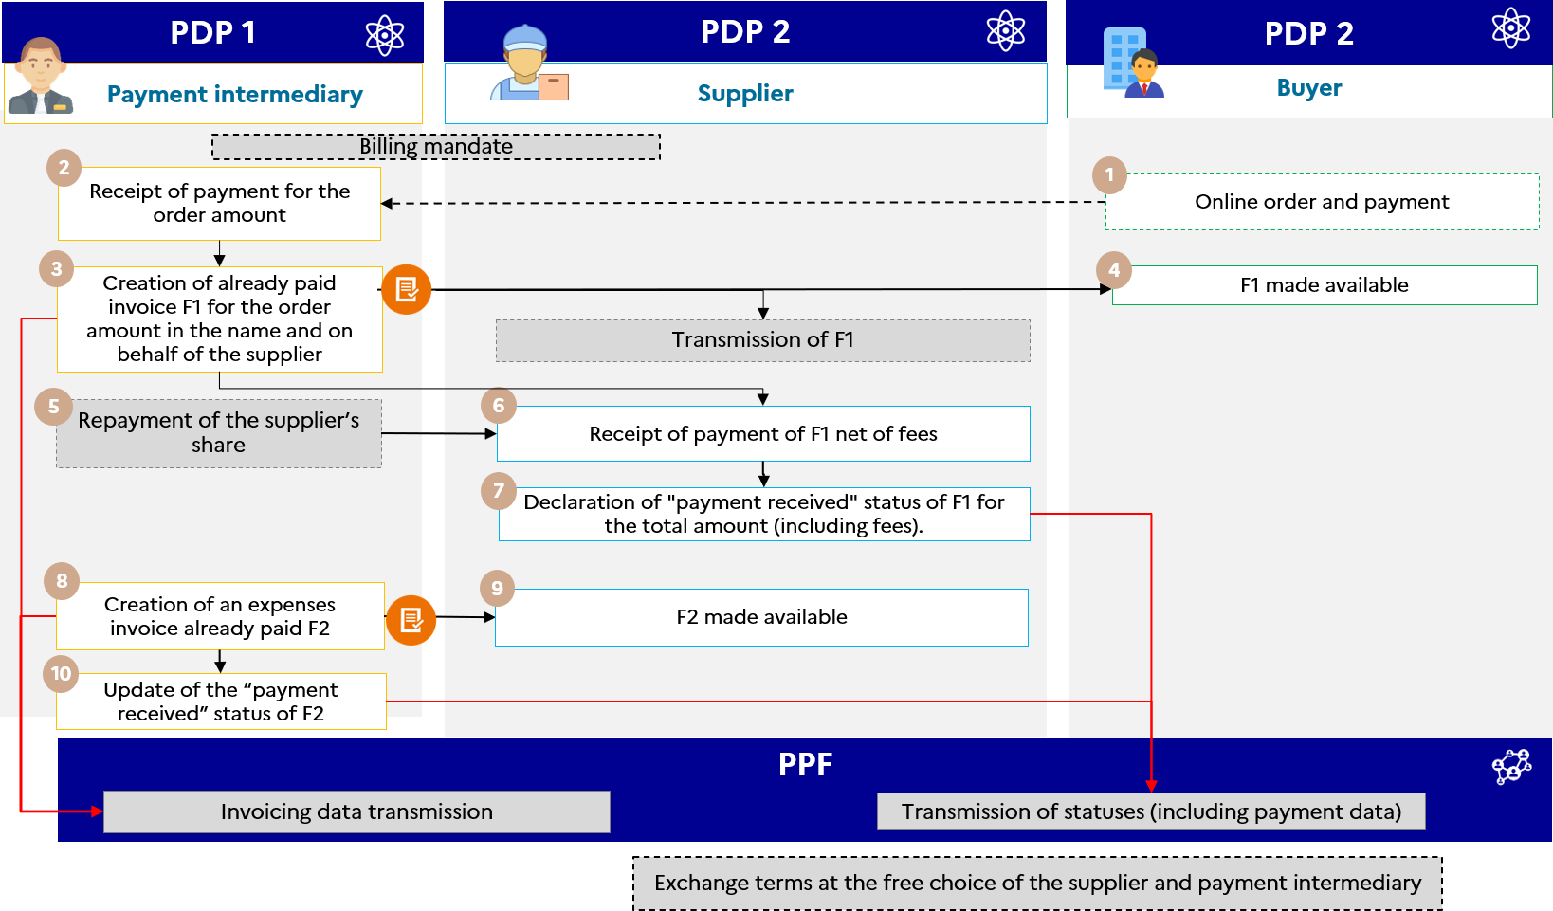

Figure 19 : Invoice payable to a third party, payment intermediary and billing mandate

The data specifics and associated management rules are :

* Invoicing framework “Submission of an invoice already paid”
* Use of the EXT-FR-FE-BG-05 block - BILLING THIRD PARTY to provide information on the payment intermediary
* Due date is identical to payment date
* Amount paid (BT-113) is equal to the total invoice amount
* Amount payable (BT-115) is equal to 0

The specifics of the life cycle or process are :

* Transmission of Flow 1 (F1) and e-reporting via supplier platform
* Transmission of Flow 1 (F2) and e-reporting via the payment intermediary platform

The steps in case no. 17b are :

|  |  |  |  |
| --- | --- | --- | --- |
| **Step** | **Step name** | **Party responsible** | **Description** |
| 0 | Signature of a billing mandate | Supplier  Payment intermediary | The supplier and the payment intermediary sign a billing mandate by which the intermediary can submit (deposit eventually) invoices on behalf of the supplier. |
| 1 | Online order and payment | Buyer | The buyer places an order on the Internet and makes the payment. |
| 2 | Receipt of payment for the order amount | Payment intermediary | The intermediary receives payment of the full amount of the order placed by the buyer |
| 3 | Creation of already paid invoice F1 for the order amount in the name and on behalf of the supplier | Payment intermediary | The intermediary's registered private platform 1 issues and transmits the invoice (flow 2) to the buyer's registered private platform 3, which makes it available to the buyer and to the supplier's registered private platform 2 (if its commercial offer so allows). In parallel, it forwards the invoicing data to the public invoicing portal. |
| 4 | F1 made available | Buyer |
| 5 | Repayment of the supplier’s share | Payment intermediary | The intermediary's registered private platform 1 transmits the amount (equal to the total amount of the order - the intermediary's commission) to the supplier's registered private platform 2. |
| 6 | Receipt of payment of F1 net of fees | Supplier | The supplier receives the amount. The supplier’s registered private platform 2 forwards the payment data to the public invoicing portal.  Step 7 applies only to supply of services, excluding the option to pay VAT on debits. |
| 7 | Declaration of the "payment received" status of F1 for its total amount | Supplier |
| 8 | Creation of an already paid fee / commission invoice F2 | Payment intermediary | The intermediary's registered private platform 1 issues and transmits the expenses invoice/commission already paid (F2 - Flow 2) to the supplier through its registered private platform. In parallel, the intermediary’s registered private platform 1 forwards the invoicing data to the public invoicing portal. |
| 9 | F2 made available | Supplier |
| 10 | Update of the “payment received” status of F2 | Payment intermediary | The payment intermediary’s registered private platform 1 forwards the payment data to the public invoicing portal.  Step 10 applies only to supply of services, excluding the option to pay VAT on debits. |

### Case 18 : Debit note management

**Definition and principle :**

A debit note is not an invoice. A debit note is a document issued by a seller to the buyer, showing an amount owed by the buyer to the seller. In principle, if accepted by the customer, this debit note has already given rise to an invoice, or will do so in the future.

Under this definition, **the debit note does not fall within the scope of electronic invoicing and does not have to be forwarded to the tax authority.** An invoice for this transaction should have been submitted.

This case does not apply to debit notes that are treated as invoices, provided that they are subject to VAT and include all the mandatory information (e.g. re-invoicing to a joint venture) enabling them to be processed.

If the debit note is issued by the buyer and refers to a debt owed by the seller to the buyer, then the seller should issue a credit note.

**In practice**, a debit note can also be issued by the buyer. Similarly, the debit note should be translated into a credit note issued by the buyer (self-billing credit note) if the buyer holds a billing mandate.

In these cases, the platform will provide for the transfer of credit notes :

* A credit note issued by the supplier,
* A credit note self-billed by the buyer.
* A factored credit note
* A factored self-billed credit note
* A prepayment invoice credit note

### Case 19a : Invoice issued with billing mandate

The billing representative carries out the invoicing in place of the supplier : it is responsible for the creation of the invoice and its transmission to the buyer ; the supplier receives payment of the invoice and is responsible for updating its status to “payment received” in the case of services provided. The invoicing data is reported by the billing representative and the payment data is reported, as applicable, by the supplier.

There are two (non-exclusive) options in this case : the use of the same platform by the supplier and its representative (option 1), or the use of two different platforms (option 2).

In both cases, the block used to provide the billing representative data is EXT-FR-FE-BG-05 - BILLING THIRD PARTY (see Annexe 1 – Format sémantique FE e-invoicing – Flux 1&2.xlsx)

* **Option 1 : delegation/authorization of the supplier’s account (same platform)**

The representative connects directly to its customer’s platform (the supplier/issuer of the invoice) in its name. The submitter’s platform is thus the issuing platform ; consequently, in the case of multiple customers, the representative must connect to as many platforms as it has customers for submission of invoices.

In this case, the electronic invoice follows the “conventional” circuit.

|  |  |
| --- | --- |
|  |  |

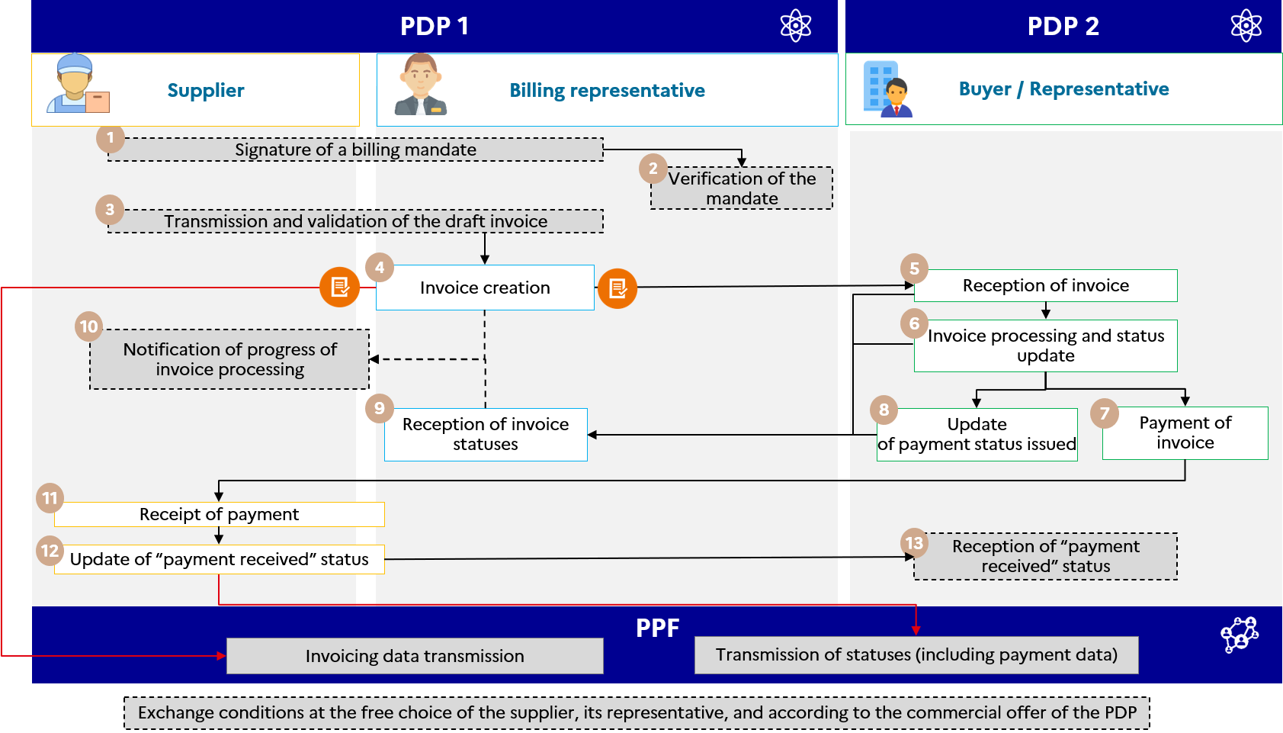

Figure 20 : Invoice issued with billing mandate (option 1)

The specifics of the life cycle or process are :

* Transmission of Flow 1 through the billing representative via the supplier platform
* Transmission of the payment e-reporting through the supplier platform
* Use of the EXT-FR-FE-BG-05 block - BILLING THIRD PARTY to provide billing representative data

The steps in case no. 19a - option 1 are :

|  |  |  |  |
| --- | --- | --- | --- |
| **Step** | **Step name** | **Party responsible** | **Description** |
| 1 | Signature of a billing mandate | Supplier  Billing representative | The supplier and the billing representative sign a billing mandate by which the representative can submit invoices on behalf of the supplier. |
| 2 | Verification of the mandate | Billing representative |
| 3 | Transmission and validation of the draft invoice | | Supplier  Billing representative |
| 4 | Invoice creation | Billing representative | The representative forwards the generated invoice (Flow 2) through the platform of its principal (the supplier). The registered private platform1 that transmits this flow 2 to the buyer's registered private platform 2 and parallel flow 1 to the public invoicing portal for transmission of invoicing data. |
| 5 | Reception of invoice | Buyer | The buyer’s PDP 2 makes the invoice available to the buyer. The buyer processes the invoice in accordance with the life cycle procedures before “payment sent” status. |
| 6 | Invoice processing and status update |
| 7 | Payment of invoice | Once the buyer has paid the supplier of the invoice, the supplier records receipt of payment |
| 8 | Optional/recommended update of payment issued statuses | The buyer transmits a life cycle with “payment sent” status to the representative. |
| 9 | Reception of invoice statuses | Billing representative |
| 10 | Notification of progress of invoice processing | Billing representative | The representative can send a life-cycle flow to inform the supplier of the progress of the invoice status, if its commercial offer allows it. |
| 11 | Receipt of payment | Supplier | The supplier records receipt of the payment |
| 12 | Update of “payment received” status | Supplier | In the case of services, the supplier updates the receipt of payment status of the invoice and declares the payment data through the public invoicing portal. |
| 13 | Reception of “payment received” status | Buyer | The supplier updates the “payment received” status through its PDP. It may transmit this status to the buyer’s PDP 2, depending on the service offer.  The PDP then sends the payment e-reporting flow to the PUBLIC public invoicing portal. |

* **Option 2 : Submitter and issuer using different platforms**
  + ***Option 2-A :*** The representative’s platform transmits the invoices to the supplier’s platform, which is then responsible for sending them to its customer.
  + ***Option 2-B :*** The representative’s platform transmits the invoices directly to the buyer’s platform.

|  |  |
| --- | --- |
|  |  |

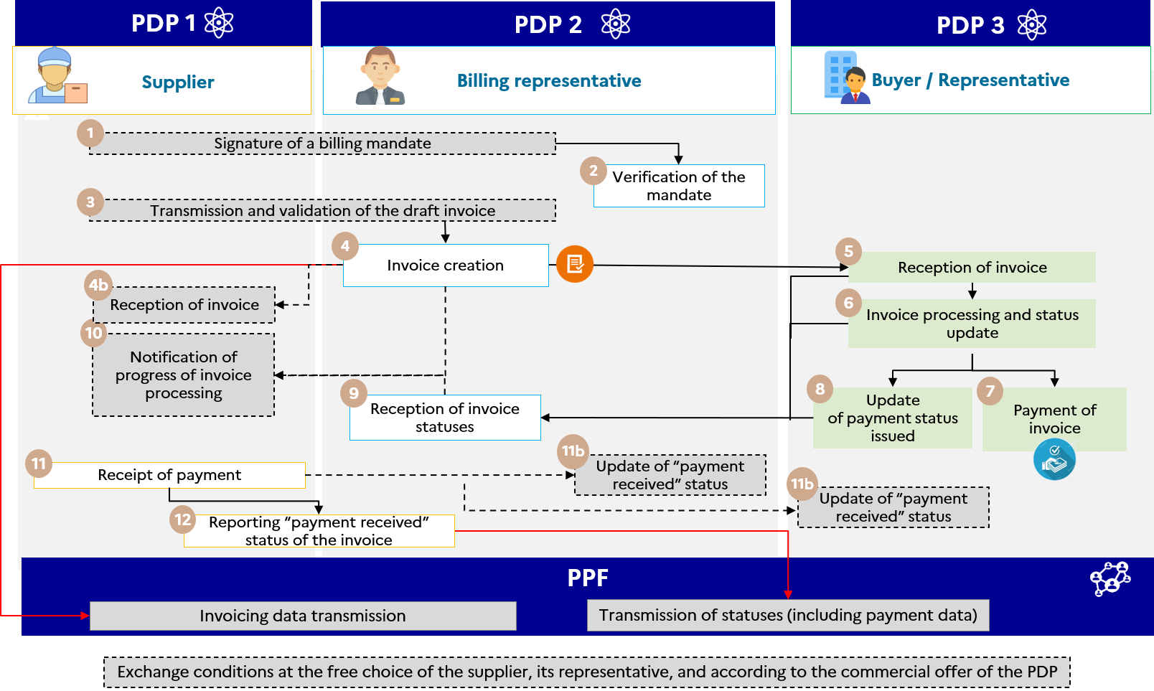

Figure 21 : Invoice issued with billing mandate (option 2)

The specifics of the life cycle or process are :

* Transmission of Flow 1 by the billing representative platform
* Transmission of the payment e-reporting by the representative or supplier platform according to the contracted billing mandate
* Use of the EXT-FR-FE-BG-05 block - BILLING THIRD PARTY to provide billing representative data

The steps in case no. 19a - option 2 are :

|  |  |  |  |
| --- | --- | --- | --- |
| **Step** | **Step name** | **Party responsible** | **Description** |
| 1 | Signature of a billing mandate | Supplier  Billing representative | The supplier and the billing representative sign a billing mandate by which the representative can submit invoices on behalf of the supplier. |
| 2 | Verification of the mandate |
| 3 | Transmission and validation of the draft invoice |
| 4 | Invoice creation | Billing representative | The representative’s registered private platform (PDP) 2 transmits a flow 2 to the buyer’s PDP 3 and in parallel to the public invoicing portal (flow 1) to forward the invoicing data. |
| 4 b and 5 | Reception of invoice | Supplier  Buyer | The supplier receives the invoice on its platform. |
| 6 | Invoice processing and status update | Buyer | The buyer’s PDP 3 makes the invoice available to the buyer. The buyer processes the invoice in accordance with the life cycle procedures before “payment sent” status. |
| 7 | Payment of invoice | Buyer | Once the buyer has paid the supplier of the invoice, the supplier records receipt of payment. |
| 8 | Update of payment status issued | Buyer | The buyer transmits a life cycle with “payment sent” status to the representative. |
| 9 | Reception of invoice statuses | Billing representative |
| 10 | Notification of progress of invoice processing | Billing representative | The representative can send a life-cycle flow to inform the supplier of the progress of the invoice status, if its commercial offer allows it. |
| 11 | Receipt of payment | Supplier | If services, the supplier receives payment and updates the status to “payment received” through its PDP. The PDP1 thus sends the “payment received” status to the third party's PDP2 and/or the buyer’s PDP 3, depending on its service offer. |
| 11b | Reporting “payment received” status of the invoice | Supplier |
| 12 | Reporting “payment received” status of the invoice | Supplier | As part of the service offer or billing mandate, PDP2 will be able to send the e-reporting flow. However, from a legal point of view, the supplier is responsible for returning the e-reporting flow |

### Case no. 19b : Self-billing

The invoice is issued by the buyer’s platform.

The data specifics and associated management rules are :

* Invoice type (BT-3) set to “389 - Self-billed invoice” ;
* If the invoice is refused, the credit note must specify :
  + Invoice type (BT-3) set to “261 - Self-billed credit note”
  + Reference to the previous invoice (BT-25)

In order to process other self-billing invoices, new types of invoices were requested from the standard.

In the case of a self-billed invoice that has been assigned receivables (factoring), the invoice type (BT-3) to be provided is "*Code to be determined* - Self-billed factoring invoice" (Awaiting the standard codes).

The factor must then be entered in the BG-10 (Recipient) block with the role code "DL" in the tag EXT-FR-FE-26 (Recipient role code).

For a self-billed prepayment invoice, the invoice type (BT-3) to be provided is "*Code to be determined* - Self-billed prepayment invoice" (Awaiting the standard codes).

For a self-billed correcting invoice, the type of invoice (BT-3) to be filled is "*Code to be determined* - self-billed correcting invoice" (Awaiting the standard codes).

For a factored self-billed correcting invoice, the invoice type (BT-3) to be proviced is "*Code to be determined* - factored self-billed correcting invoice" (Awaiting the standard codes).

For a factored self-billed credit note, the invoice type (BT-3) to be provided is "*Code to be determined* - Self-billed credit note" (Awaiting the standard codes).

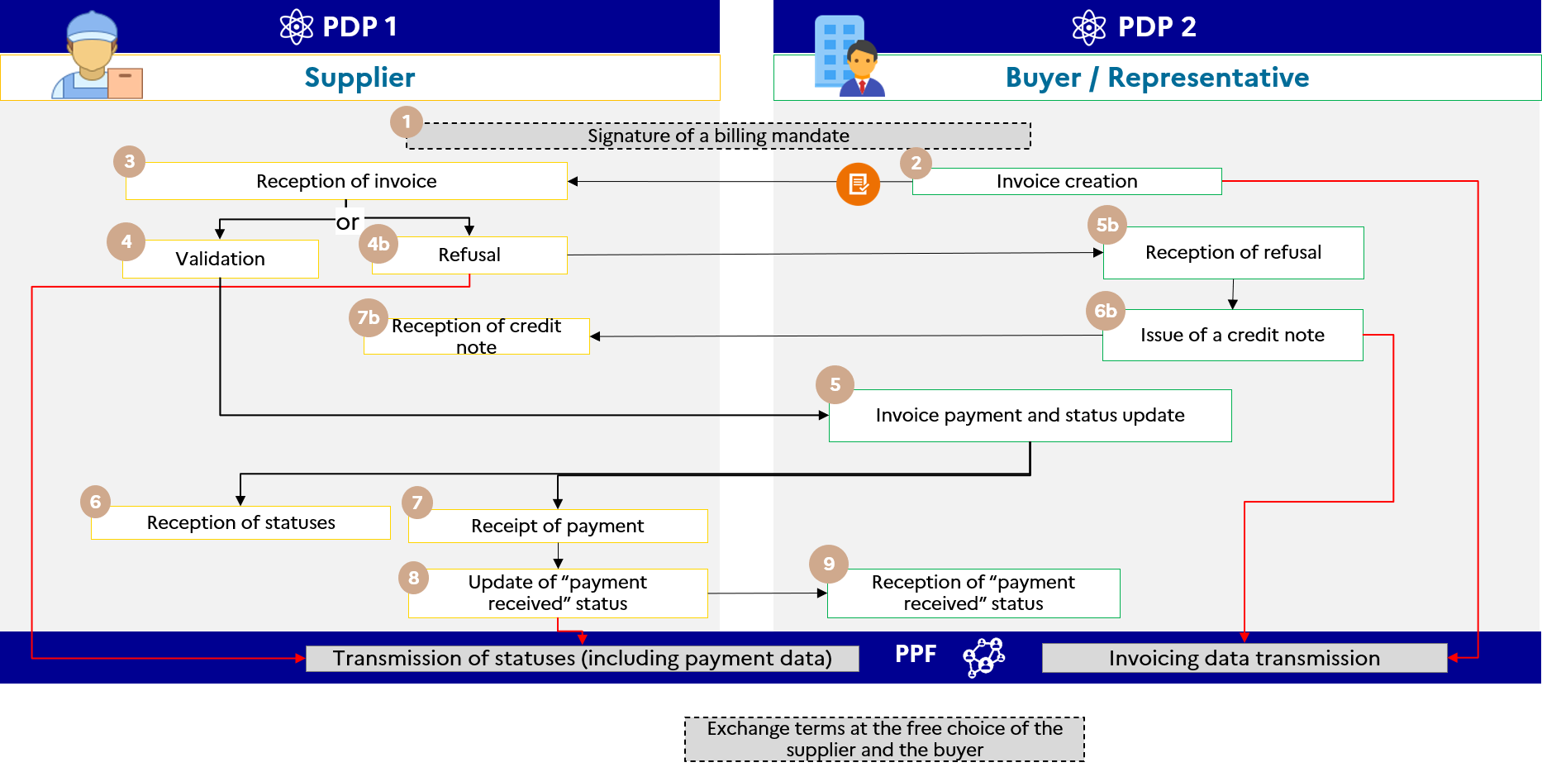

Figure 22 : Self-billing

The specifics of the associated life cycle or process are :

* A billing mandate must be established between the two parties
* The process is "reversed" : the invoice will be sent by the customer to the supplier The blocks remain the same : SELLER = supplier / provider ; BUYER = customer = invoice issuer.
* Transmission of Flow 1 by the buyer's platform.
* Transmission, where appropriate (supply of service) of thee-reporting of payment data still through the supplier platform.

The steps in case no 19b are :

|  |  |  |  |
| --- | --- | --- | --- |
| **Step** | **Step name** | **Party responsible** | **Description** |
| 1 | Signature of a billing mandate | Supplier  Buyer / representative | The supplier and the buyer/representative sign a billing mandate by which the buyer/representative can submit invoices on behalf of the supplier. |
| 2 | Invoice creation | Buyer / representative | The buyer/representative sends Flow 2 to the supplier registered private platform (PDP) and, at the same time, sends Flow 1 to the public invoicing portal for the transmission of invoicing data. |
| 3 | Reception of invoice | Supplier | The supplier’s PDP 1 receives the invoice. There are two possibilities :  1. Validation of the invoice / transmission of a life cycle to the buyer's registered private platform 2  2. Refusal of the invoice / transmission of a life cycle to the buyer’s PDP 2 |
| 4 | Validation | Supplier | The supplier’s PDP 1 transmits an invoice validation life cycle to the buyer’s PDP 2 |
| 4b | Refusal | Supplier | The supplier's registered private platform 1 transmits a refusal life cycle to the buyer's registered private platform 2 and to the public invoicing portal Rejecting the invoice cancels the associated Flow 1. |
| 5b | Reception of refusal | Buyer / representative | The buyer/representative receives the refusal of the invoice |
| 6b | Issue of a credit note | Buyer / representative | Transmission of a credit note by the buyer's registered private platform 2 to the supplier's registered private platform 1 and in parallel to the public invoicing portal (flow 1 associated to the credit note) to forward the invoicing data. |
| 7b | Reception of credit note | Supplier | The supplier’s PDP 1 receives the credit note |
| 5 | Invoice payment and optional/recommended status update | Buyer / representative | The buyer's registered private platform 2 makes the payment and may transmit in some cases a life cycle with the optional "payment sent" status to the supplier's registered private platform 1. |
| 6 | Reception of statuses | Supplier |
| 7 | Receipt of payment | Supplier | The supplier records receipt of the payment. Supplier registered private platform 1 passes the "payment received" status to the public invoicing portal and to the buyer/representative registered private platform 2 if the invoice is for supply of services. |
| 8 | Update of “payment received” status | Supplier |
| 9 | Reception of “payment received” status | Buyer / representative |

### Cases 20 and 21 : Prepayment invoice and final invoice after prepayment

A payment towards a purchase or supply of services implies a firm commitment by both parties and constitutes an advance payment. All taxable entities are required to issue an invoice for prepayments made to them (Article 289-I-1.c of the CGI) before carrying out any of the transactions referred to in a and b of I) of the aforementioned article (except where expressly provided for). VAT is payable on receipt of the advance payment for both the supply of goods and the supply of services.

The buyer must pay a first instalment on the amount due for a purchase of goods or services. For example, when a company retains the services of a removal company, it must pay part of the total amount before the move is made. The removals company issues a prepayment invoice, followed by a definitive invoice (after prepayment and following the move).

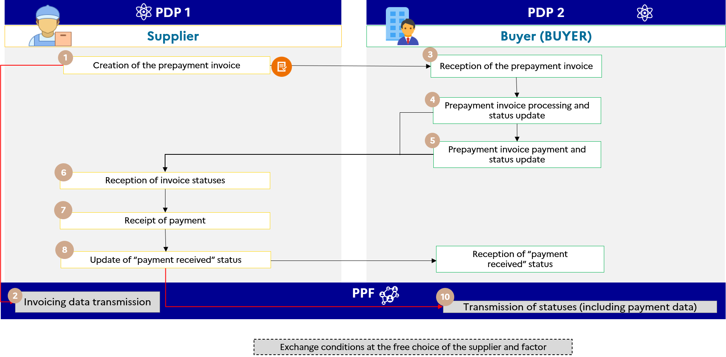

Figure 23 : Prepayment invoice

The data specifics and associated management rules are :

* The prepayment invoice must specify :
  + Invoice type (BT-3) : 386 : Prepayment invoice
  + An invoicing framework (BT-23) :

If this is an prepayment invoice not yet paid, use the following codes :

* + - B1 : Submission of an invoice for goods
    - S1 : Submission of an invoice for services
    - M1 : Submission of a double invoice (delivery of goods and supply of services that are not mutually dependent)

If this is an prepayment invoice already paid, use the following codes :

* + - B2 : Submission of an already paid invoice for goods
    - S2 : Submission of an already paid invoice for services
    - M2 : Submission of an already paid dual invoice
* The final invoice must indicate :
* Invoice type (BT-3) : 380 : Commercial invoice
* An invoicing framework (BT-23) :
  + B4 : Submission of a final invoice (after prepayment) for goods
  + S4 : Submission of a final invoice (after prepayment) for services
  + M4 : Submission of a double final invoice (after prepayment)
* The total VAT-exclusive amount and the VAT amount must correspond to the basis of assessment and the corresponding VAT still due, i.e. less the prepayment and the corresponding VAT, in order to avoid increasing the tax amount :
  + **This information should be entered on the invoicing lines** (block REFERENCE LINES IN PREVIOUS INVOICE - EXT FR FE BG 06) and the parties should be informed and able to determine the correct amount excl. tax and VAT amount. However, to get around certain limitations (particularly in terms of accounting management), it is possible to indicate the amount of the prepayment plus VAT in the invoice note, so that the company can take into consideration the total amount of the transaction in its accounts.
  + If the prepayment is not included on the invoicing lines, the VAT on the prepayment will be taken into account twice : the pre-filled VAT declaration form will have to be corrected.
* Prepayment invoice reference and date (BT-25 and BT-26)
* Optional : The amount already paid as an advance payment (BT-113)
* The outstanding amount including taxes (BT-115) : it is not mandatory to process this information, but it makes the invoice easier to read.

N.B. : In the case of final invoices, a distinction must be made between the mandatory invoice data (Flow 2) and the data to be transmitted to the tax authority (Flow 1), in particular the payment data. Thus, the prepayment will have to be included on the final invoice, whether goods or services (the invoicing framework is B4 for a final invoice on sale of goods), with the same tags as those previously mentioned (BT-25, BT-26, BT-113, BT-115)

On the other hand, as it stands, the tax authority cannot impose the transmission of prepayment data on the supply of goods in the e-reporting of payment.

The precise name is data that must be transmitted in structured format. In the meantime, the data must appear on the invoice, but not necessarily in structured format.

For prepayments, it is possible not to indicate this on the invoice if it is not determined on the date of issue of the invoice (see tolerance to BOI-ANNX-000498).

The date of payment of the prepayment will be indicated on the prepayment invoice (Article 242*h* A 10 of Annex II to the French General Tax Code (CGI)) if it is determined and if it is different from the date of issue. This data must be entered on the invoice and submitted in structured format. Moreover, the "payment received" status is not sufficient to satisfy this obligation.

A complementary field EXT-FR-FE-159 under the BT-9 is provided to indicate this remark and an ad hoc management rule : [G1.18 : If the invoice type is prepayment invoice (386) or self-billed prepayment invoice (*Code to be determined*) (*), the prepayment date must be completed only if the prepayment date is determined/known and is different from the date of issue.]

The specifics of the life cycle or process are :

* Transmission of Flow 1 and, where applicable (in case of supply of services), of the e-reporting of payment data concerning the **prepayment invoice** by the supplier platform,
* Transmission of Flow 1 and, where applicable (in case of supply of services), of thee-reporting of payment data concerning the **final invoice** by the supplier platform.

The services offered by the public invoicing portal are :

* Parties connected to the public invoicing portal will be notified if the invoice status changes.

The steps in case nos. 20 and 21 are :

|  |  |  |  |
| --- | --- | --- | --- |
| **Step** | **Step name** | **Party responsible** | **Description** |
| 1 | Invoice creation | Supplier | The invoice is created by the supplier and sent to the buyer. A flow 1 is sent in parallel by the supplier’s registered private platform (PDP) 1 to the public invoicing portal . |
| 2 | Reception of flow 1 | Supplier’s PDP |
| 3 | Reception of invoice | Buyer | The buyer receives the invoice, processes it, and updates the invoice statuses in accordance with the life-cycle procedures. Then it pays the invoice to the supplier and updates the statuses he would like through its registered private platform (PDP). |
| 4 | Processing and status update |
| 5 | Invoice payment and optional/recommended status update |
| 6 | Reception of invoice statuses | Supplier | The supplier receives the invoice statuses through its PDP and records receipt of payment of the invoice. Then, it updates the "payment received" status. |
| 7 | Receipt of payment |
| 8 | Update of “payment received” status |
| 9 | Reception of “payment received” status | Buyer | The buyer’s PDP 2 makes the “payment received” status available to the buyer. |
| 10 | Reception of payment data e-reporting flow | public invoicing portal | The supplier’s PDP 1 accordingly sends the payment e-reporting flow to the public invoicing portal. |

### Case 22a : Invoice paid with discount on supply of services for which VAT is due on receipt of payment

Discounting is an opportunity for a customer to pay its invoice early in exchange for a discount. The discount amount does not appear on the invoice issued, only a remark detailing the discount conditions is shown on the invoice.

For supply of services, the tax authority may take the discount granted into account using the forwarded payment data. In fact, the “payment received” status will be extended to include the amount received (total including VAT – discount).

For deliveries of goods or operators that have opted for debits, as well as net tax discounts, refer to case 22b.

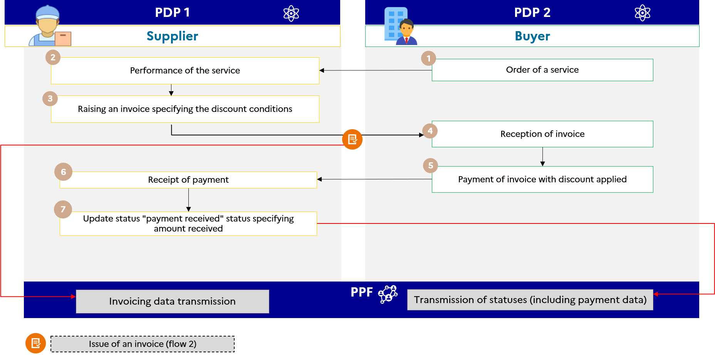

Figure 24 : Invoice paid with discount (for supply of service, VAT payable on collection)

The data specifics and associated management rules are :

* Invoice note (BT-21/BT-22) with
  + Subject code : “AAB”
  + Text : discount information

The specifics of the life cycle or process are :

* Transmission of Flow 1 and e-reporting of payment data through the supplier platform ;
* The creation of a discount does not require the issue of a credit note if it is stated on the invoice that the deductible tax is limited to the price actually paid by the buyer.

The services offered by the public invoicing portal are :

* Parties connected to the public invoicing portal will be notified if the invoice status changes.

The steps in case no. 22a are :

|  |  |  |  |
| --- | --- | --- | --- |
| **Step** | **Step name** | **Party responsible** | **Description** |
|  | Invoice creation showing the amount excluding VAT, the VAT, discount percentage and due date and the remark relating to the amount of VAT deductible by the buyer | Supplier | The invoice is created by the supplier and sent to the buyer. A flow 1 is sent in parallel by the supplier’s registered private platform (PDP) 1 to the public invoicing portal. |
| 2 | Reception of flow 1 | Supplier’s PDP |
| 3 | Reception of invoice | Buyer | The buyer receives the invoice, processes it, and updates the invoice statuses in accordance with the life-cycle procedures. Then, before the due date, it pays the supplier the amount including VAT reduced as a percentage of the amount excluding VAT and the VAT on this discounted amount excluding VAT. It updates the statuses through its PDP. |
| 4 | Processing and status update |
| 5 | Invoice payment and status update |
| 6 | Reception of invoice statuses | Supplier | The supplier receives the invoice statuses through its PDP and records receipt of payment of the invoice. Then, it updates the "payment received" status of the amount received after discount. |
| 7 | Receipt of payment |
| 8 | Update of “payment received” status |
| 9 | Reception of “payment received” status | Buyer | The buyer’s PDP 2 makes the “payment received” status available to the buyer. |
| 10 | Reception of payment data e-reporting flow | public invoicing portal | The supplier’s PDP 1 accordingly sends the payment e-reporting flow to the public invoicing portal. |

### Case no. 22b : Invoice paid with discount in the case of delivery of goods (or supply of services with the option to pay VAT on debits)

When applying a discount where the supplier has made a delivery of goods or opted to pay VAT on debits, the payment data is not forwarded and is not taken into account by the tax authority. Hence, the tax authority cannot know the discount granted by the supplier and reduce its collected VAT by the same amount.

The supplier could notify the tax authority of the application of a discount by issuing a credit note. This is an option, as the discount credit note is not provided for in the texts.

This option is open to enterprises wishing to avoid retroactive regularization of collected VAT to adjust for over-collection

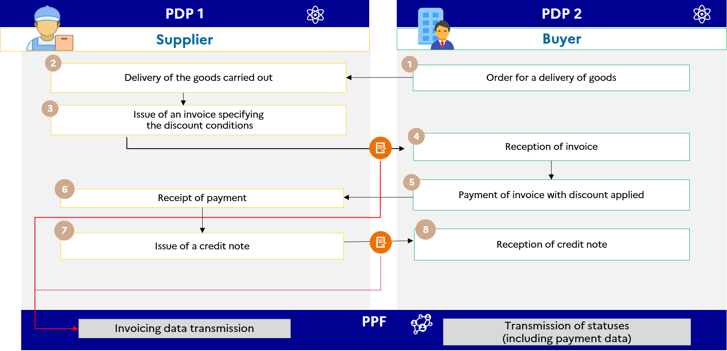

Figure 25 : Invoice paid with discount (delivery of goods, supply of service with VAT on debits)

The data specifics and associated management rules are :

* On the initial invoice :
  + Invoice note (BT-21/BT-22) with
    - Subject code : “AAB”
    - Text : discount information
* If credit note, amount excl. tax = discount reported excl. tax ; VAT = VAT on discount amount granted / calculated
  + Can use invoice type code (BT-3) : 381 or 261 (credit note or self-billed credit note)
  + A discount may also be net of tax ; in this case, the following must be added to the credit note :
    - VAT type code (BT 118) : I
    - Code of grounds for VAT exemption (BT-121) : VATEX-CNWVAT

This code applies to all types of net tax assets.

The specifics of the associated life cycle or process are :

* Transmission of invoice (flow 2) specifying the terms for applying the discount
* Transmission of life cycle (flow 6)
* Transmission of a credit note (flow 2) indicating the amount of the discount applied

### Case 23 : Self-billing flow between a private individual and a professional

A private individual who repeatedly sells or offers services to a professional exercises a business activity and is therefore an entity subject to VAT.

The private individual may not be subject to VAT if eligible for the basic VAT exemption scheme (Article 293B of the CGI) but falls within the scope of electronic invoicing.

In most cases, it is the recipient (energy supplier) who invoices. For self-billing by the customer, refer to use case no. 19b of the external specifications

There is an exception for sales of solar power by private individuals when the power of the installation does not exceed 3 kWp (see BOI BIC CHAMP 80 30 and BOI-TVA-LIQ-30-20-90-20, § 260). These operators are not entities subject to VAT and do not therefore fall within the scope of e-invoicing or e-reporting.

### Case 24 : Management of deposits

Deposits are defined as amounts paid as a cancellation forfeit (Article 1590 of the Civil Code) : the buyer can thus cancel the sale and renege on the purchase by forfeiting this amount. If the deposit constitutes compensation, i.e. it does not correspond to payment for a service (in the absence of a consideration), it is not subject to VAT.

In business affairs, amounts paid in advance more frequently constitute part payment of the sales price, with no possibility for the parties to retract.

Deposits constitute compensation for the purpose of repairing commercial damage and are not subject to VAT ; they do not fall within the scope of e-invoicing or e-reporting. It is recommended that the nature of this sum is specified in the contract or receipt given to the buyer.

### Case no. 25 : Management of gift vouchers and gift cards

Gift vouchers and gift cards may be single or multiple use depending on whether or not the place of delivery of the goods or services and the VAT due on those goods or services are known at the time of their issue.

**Examples** :

* A card giving the holder the right to attend a certain number of performances at a given venue, for which the place of taxation and the VAT rate are determined, constitutes a single-use voucher.
* A gift card that gives access to different goods or services in a network of shops, for which the place of taxation and the VAT rate are indeterminate, constitutes a multiple-use voucher.

1. Single-use vouchers (SUV)

Step 1 - Issue of the voucher :

The sale of a single-use voucher is subject to VAT where, at the time of its issue, the place of delivery of goods or supply of services to which the voucher relates and the corresponding VAT are known (basis of assessment, rate, territoriality). The sale of a single-use voucher is subject to VAT on each transfer and this VAT is payable under the conditions applicable to the underlying transaction : delivery of goods or supply of services (see Article 269 and BOI-TVA - BASE-20-40). Hence, if the underlying transaction in connection with the SUV is delivery of goods, VAT will be payable on handing over the voucher. If the underlying transaction in connection with the voucher is supply of services, VAT will be payable on receipt of payment of the voucher purchase price. The physical handing over of goods or the actual supply of services in exchange for an SUV accepted in full or partial consideration by the supplier or service provider is not considered a separate transaction.

Each subsequent transfer of the single-use voucher will also be subject to VAT, payable under the same conditions as for the first transfer.

Each transfer of the single-use voucher by a taxable entity will fall within the scope of e-invoicing (sale of gift cards to a taxable entity) or e-reporting (sale to private individuals) for the company that sells it.

Step 2 - Use of the gift voucher

The use of the single-use voucher by its beneficiary (holder of the voucher) in exchange for delivery of goods or supply of services is not subject to VAT.

However, where the issuer of the SUV is other than the service provider or supplier of the services or goods in connection with the SUV, the supplier or service provider is deemed to have delivered or supplied the goods or services in connection with the voucher to that taxable entity, and must accordingly invoice this service (e-invoicing) to the issuer.

The VAT on this transaction will be payable under the same conditions as the underlying transaction. Hence, when the voucher gives access to a service, VAT will be payable on receipt of payment of the sums invoiced by the service provider to the issuer. When the voucher gives access to goods, VAT is payable at the time of delivery of the goods in exchange for the voucher.

Where the issuer of the voucher is also the supplier or service provider, handing over the voucher in exchange for goods or services to the customer is not subject to VAT when it is not considered a separate transaction from the sale of the voucher (see step 1).

Commissions or management fees may be charged throughout the voucher marketing chain and are subject to VAT. They must be invoiced separately, including the related VAT, and this invoicing will fall within the scope of e-invoicing.

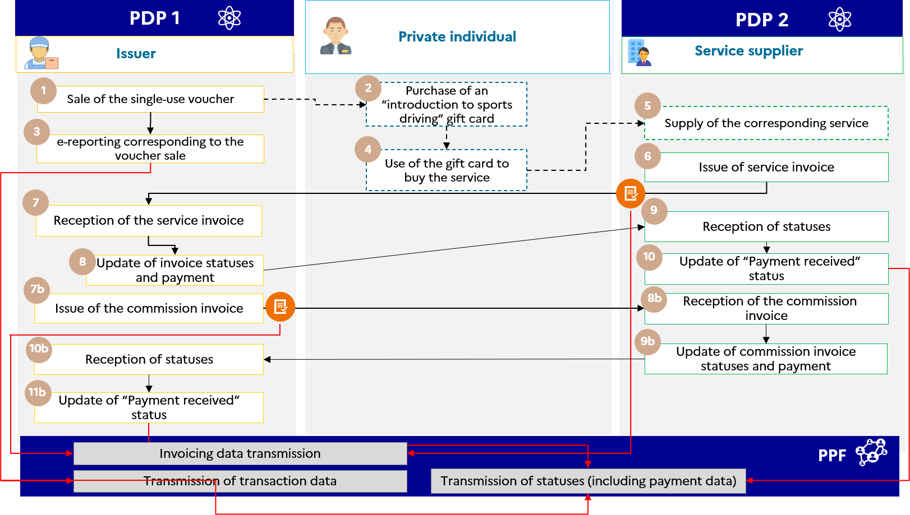

Figure 26 : Management of single-use vouchers

1. Multiple-use vouchers (MUV)

Step 1 - Issue of the voucher

The sale of a multiple-use voucher is not subject to VAT when, at the time of its issue, the place of delivery of the goods or supply of services and the VAT due on these goods or services are not known.

The sums paid for the purchase of multiple-use vouchers are outside the scope of VAT and do not fall within the scope of the electronic invoice or e-reporting.

Step 2 - Use of the gift voucher

The use of the multiple-use voucher by its beneficiary (holder of the voucher) in exchange for delivery of goods or supply of services is subject to VAT. It is a transaction between a taxable entity and a non-taxable entity that falls within the scope of e-reporting.

VAT is payable under the same conditions as the underlying transaction. Hence, the tax is payable on the date the supplier accepts the multiple-use voucher when it is a voucher that gives access to goods.

If the multiple-use voucher gives access to a service to its beneficiary (holder of the voucher), tax is payable on receipt of payment for the price of the transaction, i.e. on receipt of payment of the reimbursement made by the issuing company.

Where the issuer of the voucher is also the service provider, VAT is payable on handing over the voucher in exchange for a service.

Commissions or management fees may be charged throughout the MUV marketing chain and are subject to VAT. They must be invoiced separately, including the related VAT, and this invoicing will fall within the scope of e-invoicing.

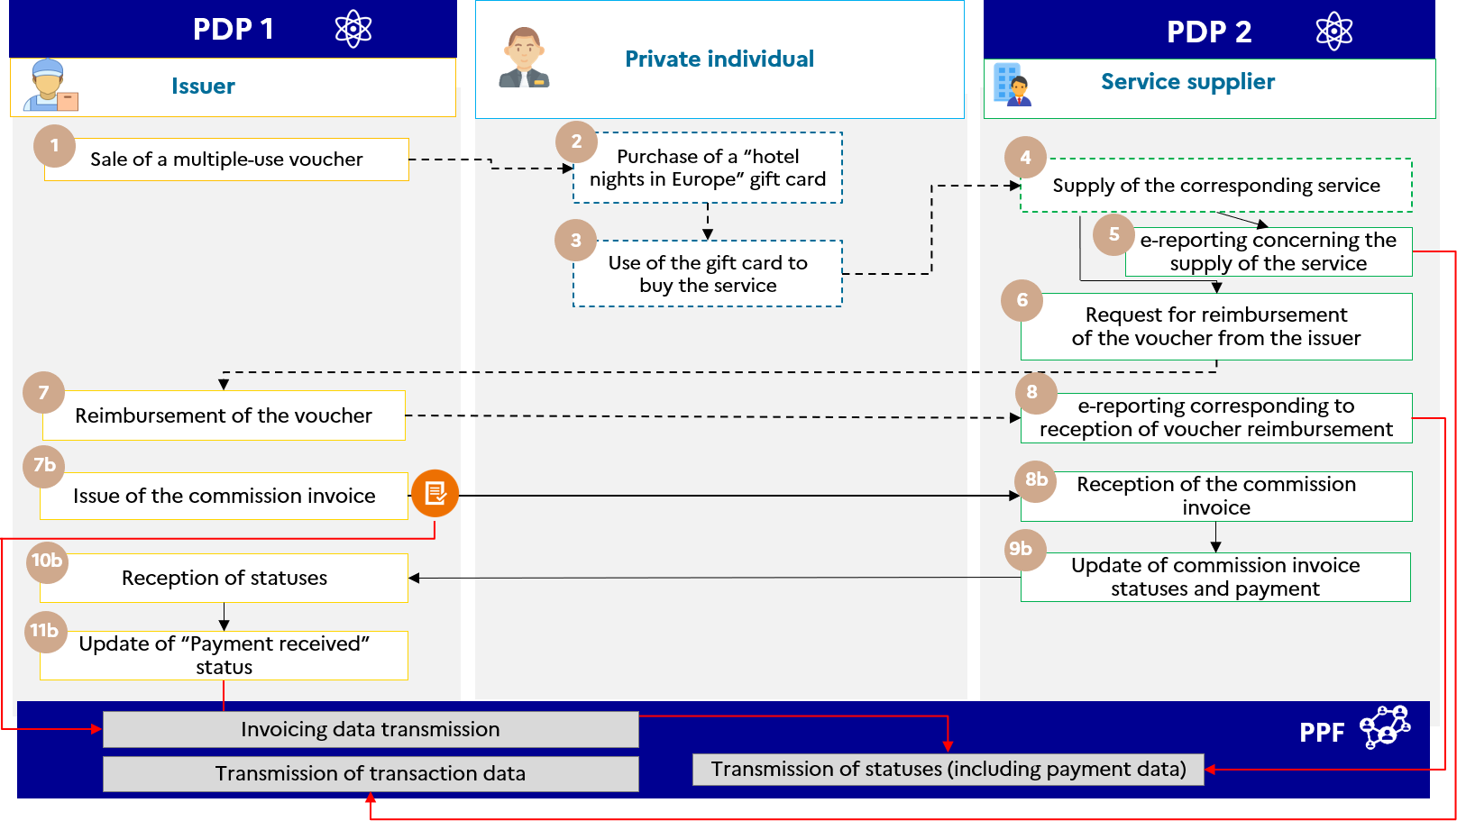

Figure 27 : Management of multiple-use vouchers

### Case 26 : Invoices with contractual reserve clause

The case of invoices paid 95% by the customer with a contractual reserve clause resulting in a holdback of 5%.

* **Supply of goods** :

In the absence of e-reporting of the payment data, this holdback does not affect the VAT until it becomes final.

In the case of supplies of goods, the amount received does not affect the chargeability of VAT. The exercise of the holdback should give rise to a credit note by the supplier.

* **Supply of services** :

Taken into account indirectly through the e-reporting of payment data. Only amounts received give rise to VAT.

E-reporting of payment data : taking into account the partial payment of 95%. Holdback of 5% to be reported once paid.

In the case of a partial payment, only the VAT on the amount received will be chargeable.

The exercise of the holdback should give rise to a credit note by the supplier. In the absence of payment of the 5%, no e-reporting of the remaining 5%.

### Case 27 : Management of toll receipts

In principle, the toll receipts collected by a taxable entity fall within the domain of electronic invoicing. However, some doctrinal tolerance is permitted in respect of their official processing.

Receipts issued at toll plazas are considered to be invoices when they include :

* the VAT rate and amount
* a sequential issue number
* a space reserved for the user

The customer is not known to the issuing taxable entity : the transactions can be likened to B2C transactions.

**Solution :**

* **E-reporting of transactions** by transmission of overall data on a daily basis
* The tax authority may pre-fill the VAT collected from the issuer but not the VAT deductible for the taxable user
* No information to be added to receipts issued by automatic toll machines
* ***E-invoicing in case of subscription or charge card by a taxable entity***
* Invoices issued in the scope of subscriptions or charge cards must include all mandatory information

### Case 28 : Management of restaurant bills

In principle, restaurant bills issued to a taxable entity fall within the domain of electronic invoicing. However, receipts for values below €150 before VAT will enjoy a degree of doctrinal tolerance in respect of their official processing.

* Bills of under €150 excluding VAT need not include customer identification information.
* When the amount of the service is below €25 and the customer (non-trader) does not request it, the service provider is not required to issue a bill.

To take account of this tolerance, the solution chosen is :

* **E-reporting of transactions below €150 excluding VAT** (including those below €25) by transmission of global data on a daily basis, unless expressly requested by the taxable client.
* **E-invoicing mandatory for bills** to a taxable entity of **over €150 before VAT**.

Management of a bill where the customer is a **non-taxable entity** :

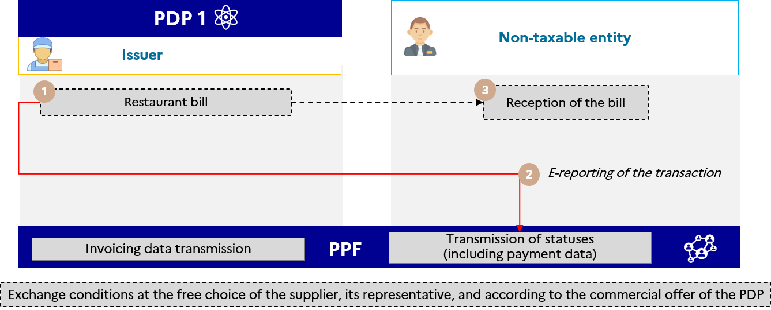

Figure 28 : Management of restaurant bills

Management of a note to which the customer is a **taxpayer** but is not determined as such at the time of the transaction or note less than €150 excluding tax :

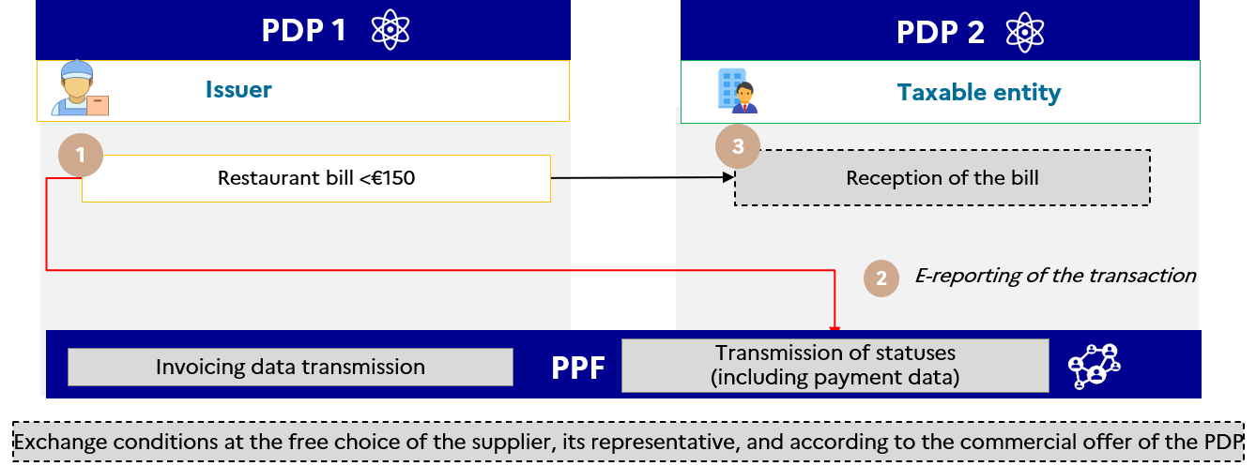

Figure 29 : Declaration of transaction data for bills below 150 euros

Management of a note to which the customer is **a taxpayer** as indicated below, or notes exceeding €150 excluding tax :

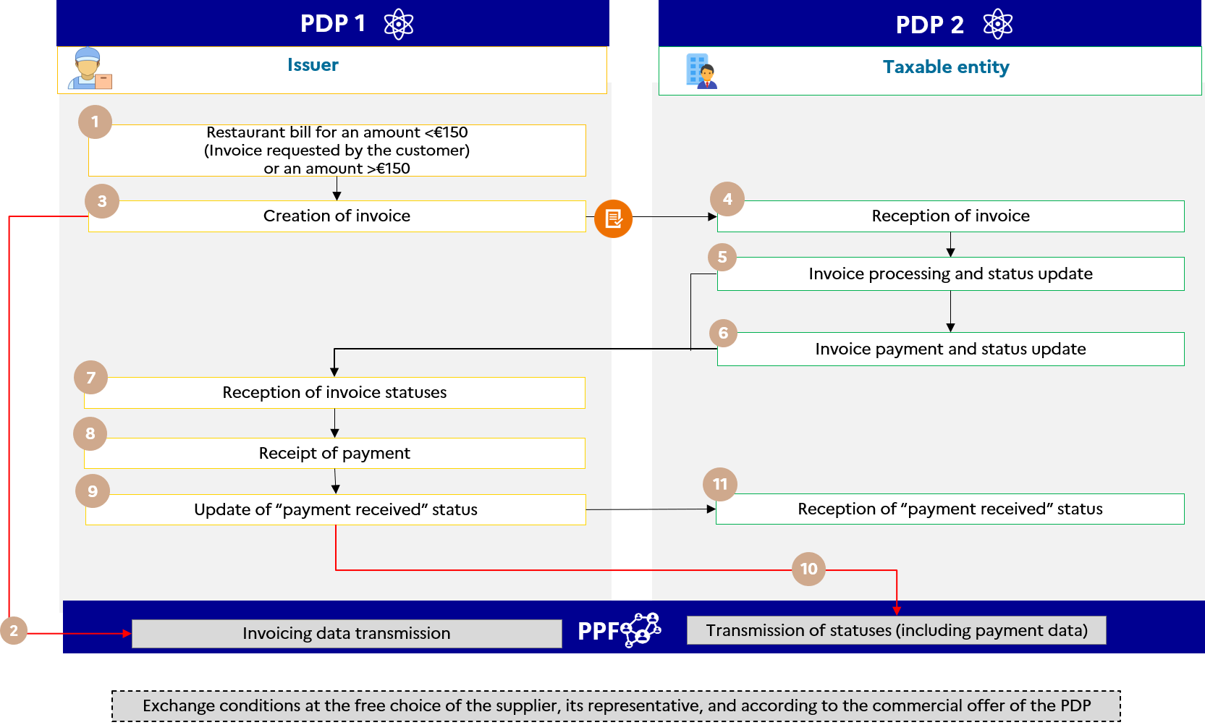

Figure 30 : Issuance/transmission of an electronic invoice for notes exceeding €150

### Case 29 : Single taxable entity as defined in Article 256 C of the CGI

This management case concerns transactions external to the single taxable entity, i.e. transactions between a member of a single taxable entity and a third party to that single taxable entity.

Transactions between members of a single taxable entity are beyond the scope of electronic invoicing and will not be managed by the public invoicing portal (see registered private platform services offer).

As part of bringing VAT group in France into compliance with the VAT directive 2006/112/EC (already implemented in 20 Member States of the European Union), a VAT identifier and SIREN will be created for the single taxable entity who becomes solely liable for VAT for all members making up the group. Where appropriate, these two identifiers will be indicated, in addition to their own identifiers, on all invoices issued by the members of the sole taxable entity on its behalf.

The conditions for adding this data to the standard are under consideration.

In case of single taxable entities :

* The data relating to the member of the sole taxable entity must be included in the SELLER block (BG-4). The field BT-29a will be used to inform the SIREN of the sole taxable entity. The "Member of a single taxable entity" must be entered for all invoices issued under a single taxable entity in the invoice note in BT-21 (see G1.52), with the "TXD" note subject code.
* In the absence of a single taxable entity block in EN16931, the data relating to the single taxable entity, other than SIREN, must be included in the TAX REPRESENTATIVE OF THE SELLER block (BG-11).

The management rules for the single taxable entity are in particular rules G 1.76, G1.78, G1.79 and G1.52 (see Annex 7).

### Case no. 30 : VAT already collected - Transactions initially processed under B2C e-reporting, subject to subsequent invoicing

This case illustrates the management of transactions between taxable entities subject to e-invoicing that have been recorded using software or a cash register (B2C transaction).

It applies more generally to all cases where the transaction is registered in a cash register, is subject to a B2C e-reporting and is then subject to an electronic invoice at the request of the customer. It may be used in particular in the case of restaurant bills which would be subject to a later invoice.

E.g.

A florist simultaneously supplies of services (as event manager) and sells goods (plants) to a B2B (hotel) and B2C (private individual) clientele. It records its transactions using software or a cash register. It is subject to electronic invoicing requirements for its B2B transactions and e-reporting requirements for its B2C transactions. Under these requirements, it must submit its transaction and payment data at a frequency F.

Step 1 - Accounting for the B2C transaction

The florist makes a B2C transaction paid in cash. The Z report for the business day refers to all transactions made on that day. The florist submits its cumulative transaction data (flow 10.3) in an e-reporting flow and, if it also supplies a service, in an e-reporting flow (flow 10.4) for each day of the e-reporting period.

Step 2 - Issue of a B2B invoice

One of the florist’s customers turns out to be a professional and asks for an invoice to be able to exercise the right to deduct VAT for the transaction.

The florist then issues an electronic invoice. To avoid double accounting for the base amount excluding VAT and the VAT, this invoice must specify “VAT already collected” in the invoicing framework created for this purpose. This invoicing framework allows the forwarding of the corresponding invoice data (flow 1) to the tax authority, while indicating that it has already been forwarded by e-reporting (flows 10.3 and 10.4), thus enabling the customer’s deductible VAT to be determined while avoiding double accounting for the trader.

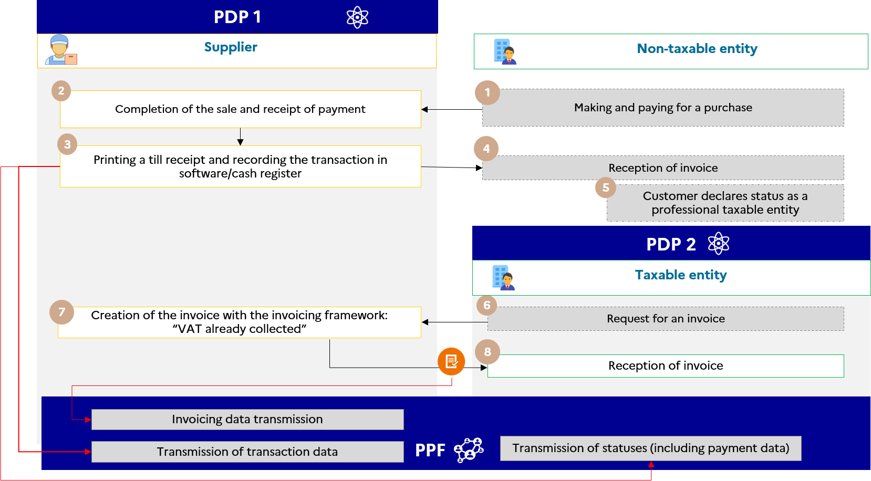

Figure 31 : Management of invoices with VAT already collected

The data specifics and associated management rules are :

* Invoicing framework (BT-23) : B7/S7/M7 (“VAT already collected”)

The specifics for forwarding invoicing/transaction and payment data are :

* Forwarding of e-reporting of the cumulative transaction data (flow 10.3) and payment data (flow 10.4) recorded by the cash register software
* Forwarding of the invoice with the invoicing framework “VAT already collected” (flow 2)

The "VAT already collected" invoicing framework can be used in other situations, in particular in the case of invoices to be issued when VAT has been declared by a company on its VAT declaration form for the period for which it is due and the invoice is subsequently issued.

### Case 31 : "Mixed" invoices mentioning a main transaction and an accessory transaction

This case illustrates the management of “mixed” or “single complex transactions“ (comprising several categories of mutually-dependent transactions). The transaction category is either a delivery of goods or a supply of service.

Under Article 257 ter II of the CGI, these are activities whose elements are so closely linked that they constitute, objectively, a single and inseparable economic service whose deconstruction would be of an artificial nature.

Principle :

In the event that an invoice refers to two transactions : a first transaction considered to be the main transaction, and a second transaction considered to be a secondary transaction (associated with the main transaction). The methods for forwarding the invoicing/transaction data and payment data for these two transactions are then determined according to the category of the main transaction. In effect, payment data should only be forwarded for transactions falling within the supply of services category in order to determine the basis of assessment of VAT.

For e-reporting not linked to an invoice and not including in a flow 10.1 (invoice data transmission flow) : it is up to the issuer to define the category of the transaction (delivery of goods or supply of service) for the transmission of transaction data.

In e-invoicing : a mandatory indication on the invoice will indicate the category of the transaction.

E.g.

A clothes shop offers a bespoke alterations service independently of the sale of its products. Transactions are in cash with immediate receipt of payment. They are recorded using software or a cash register.

Payment data must be forwarded for transactions falling within the supply of services category in order to determine the basis of assessment of VAT :

* If a product has to be altered following the sale, the alteration is considered as being ancillary to the sale. It will not therefore be subject to e-reporting of payment.
* If a customer wishes to have a garment altered (purchased as part of another transaction), then this alteration will be considered as the main item and will be subject to e-reporting of payment for the services invoiced (excluding the option to pay VAT on debits).

Case 1 : the alteration is associated with the sale of a suit => the main transaction is a supply of goods.

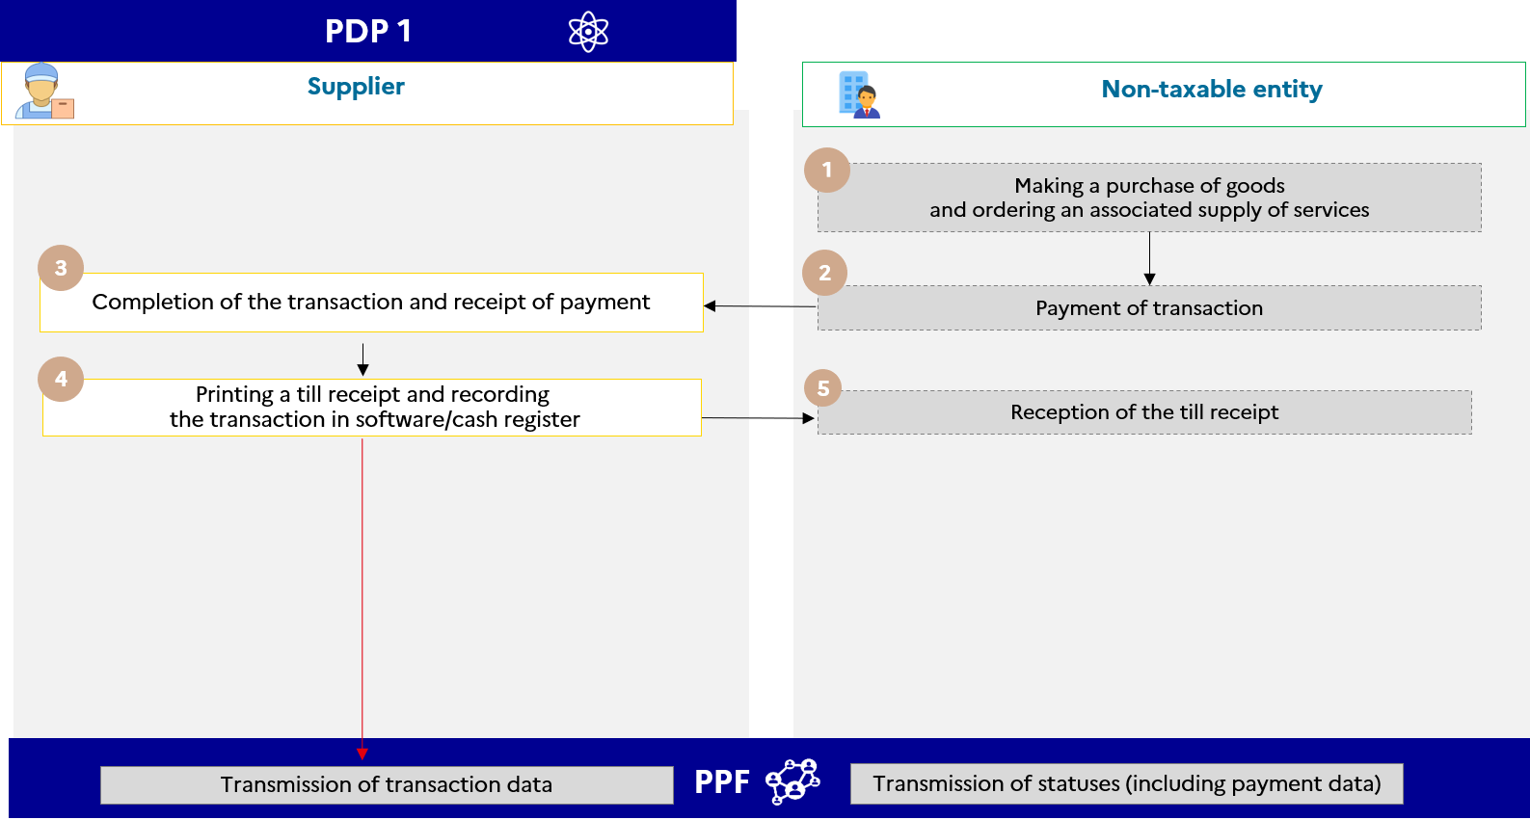

Figure 32 : Mixed invoice with main and accessory transactions categorised as a sale (case of a sales adjustment)

Case 2 : the alteration is the main operation of the transaction (with or without an ancillary sale) => transaction is a supply of service.

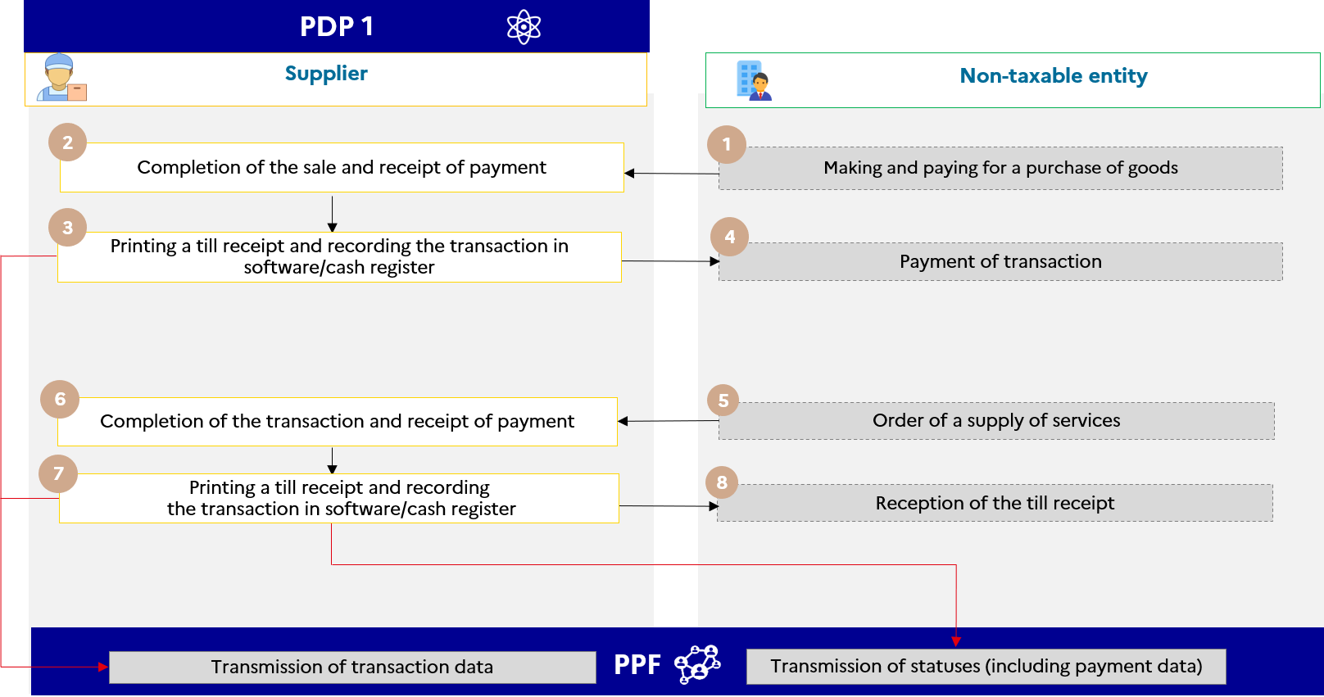

Figure 33 : Invoice with main transaction = supply of service (case of adjustment with or without sale)

The specifics for forwarding invoicing/transaction and payment data are :

* Transmission of an e-reporting of the cumulative transaction data (flow 10.3) recorded by the checkout software, by category of transaction performed (see rule G1.68 in Annex 7) ;
* Forwarding of e-reporting of the cumulative payment data (flow 10.4) recorded by the cash register software, only for transactions in the supply of services category (TPS1).

**Important (1) :**  A distinction should be made between invoices for so-called "mixed" transactions and invoices for so-called "double" transactions which relate to an invoice comprising both a supply of goods and a supply of service. Although a category of double transactions is included in the mandatory data to be transmitted to the tax authority to take account of the operators' practices, **separate invoices should be drawn up** for supplies of goods and supplies of service, taking into account the different rules of chargeability of VAT, in order to identify to which transactions the e-reporting of payment relates.

**Important (2) :**  This case is also to be distinguished from the sale of *"packages"* comprising elements subject to a separate VAT regime. In this case, as the EU standard and the UBL and CII formats stand, each item will have to be treated separately in the invoice (e.g. in the case of the sale of a toy-book, one invoice line will have to be used for the book and one line for the toy).

### Case 32 : Monthly payments

This management case illustrates the methods for transmission of payment data relating to monthly payments made before an invoice is issued.

In this case, the monthly payments are reported by means of an e-reporting of transaction (corresponding to a delivery of goods or a supply of service subject to VAT) supplemented by an e-reporting of payment. The adjustment invoice will be sent :

* in a domestic B2B transaction via an e-invoicing flow (flow 2)
* in the context of an international B2B or B2C transaction via an e-reporting flow (flow 8, flow 9 or flow 10)

E.g.

An energy supplier offers its customers the option of monthly payments based on an estimate of their annual consumption. The energy supplier issues an adjustment invoice at the end of the year, with the amount calculated using the actual consumption of each customer.

Case 1 : The adjustment invoice shows a balance payable and no option to pay VAT on debits

Case 1-a : The adjustment invoice shows a balance payable (no option on supplier debits) :

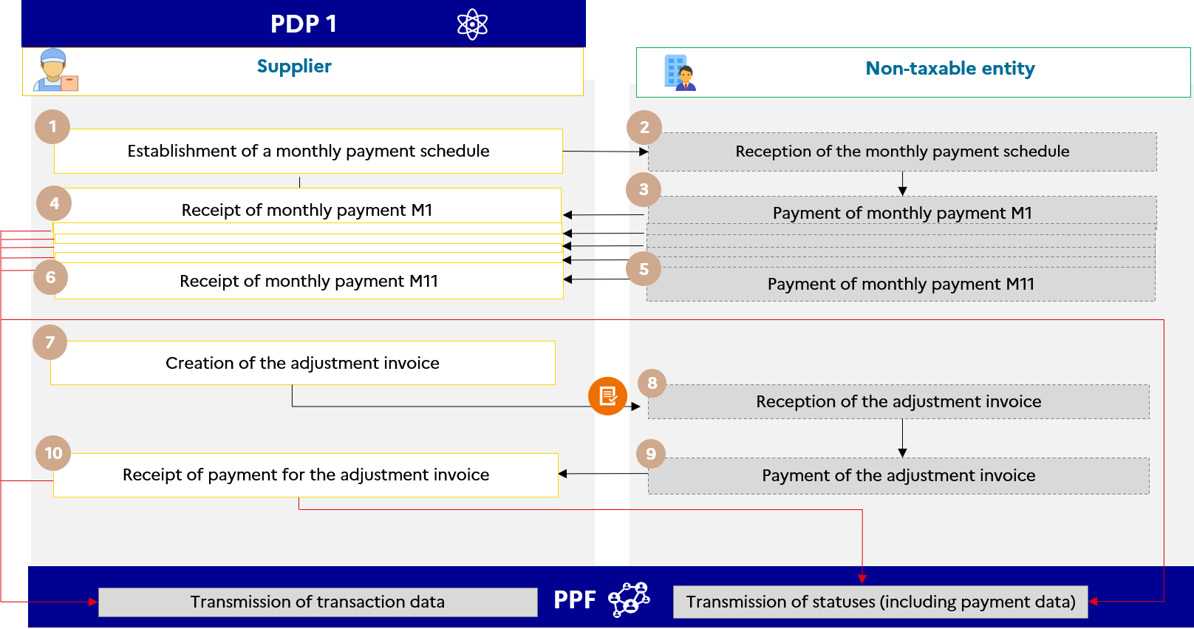

Figure 34 : Monthly payments and supplement to be paid as part of a B2C transaction (Option 1a)

The specifics for forwarding invoicing/transaction and payment data are :

* Forwarding of e-reporting of the cumulative transaction data (flow 10.3) and payment data (flow 10.4) relating to the monthly payments received for the period if applicable (supply of services),
* Issue of an adjustment invoice showing the additional amounts to be paid to the customer (outside the circuit), the total amount exclusive of tax and VAT, and a reminder of the monthly instalments already paid
* In parallel, forwarding of net e-reporting equal to the amount of the adjustment invoice minus the prepayments
* Forwarding of payment data (flow 10.4) including the amount received, corresponding to the net amount of the adjustment invoice.

Case 1-b : The adjustment invoice shows a balance payable (option for the supplier to pay VAT on debits)

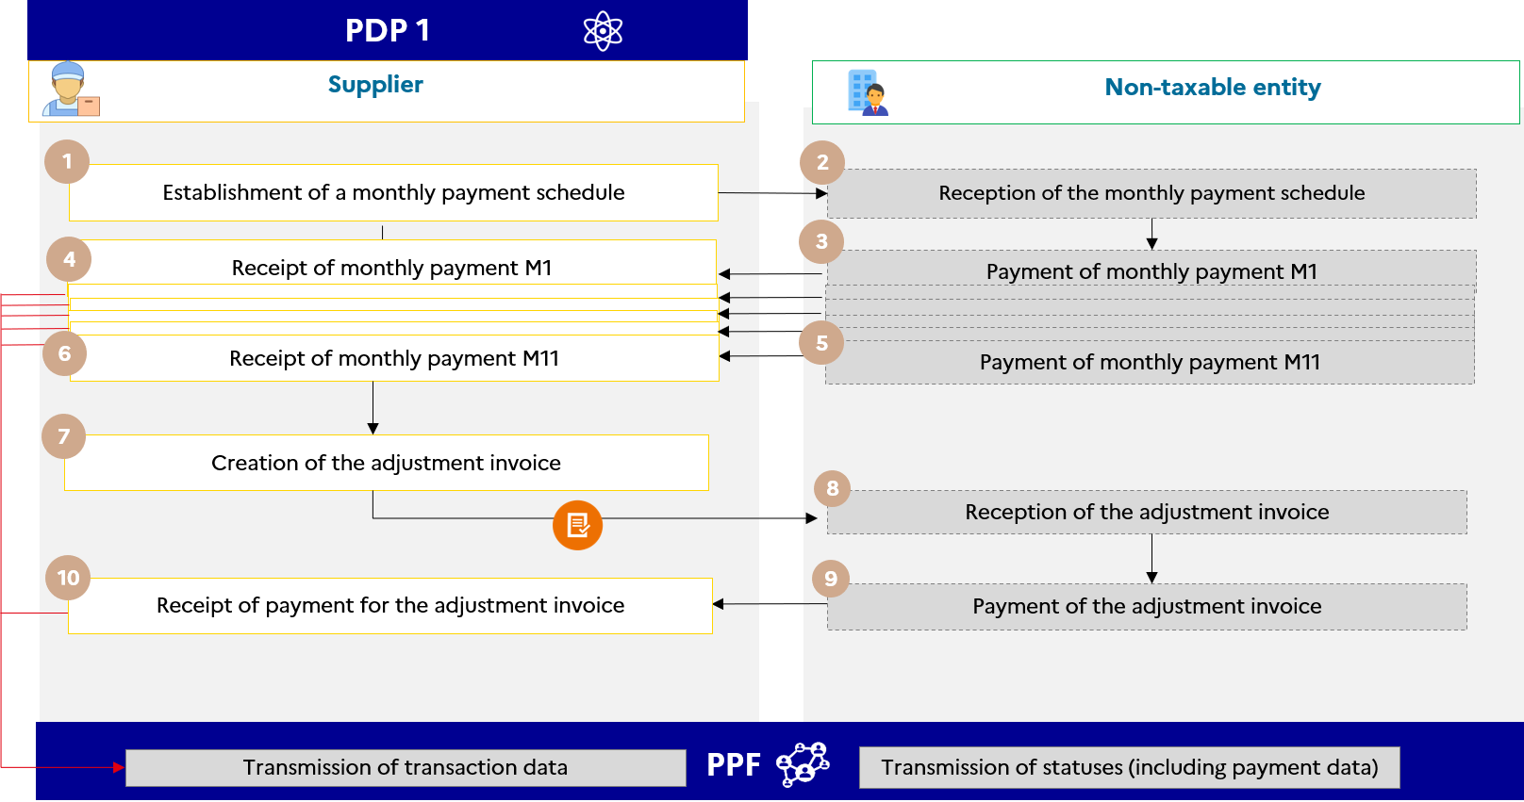

Figure 35 : Monthly B2C payments and top-up (option 1b)

The specifics for forwarding invoicing/transaction and payment data are :

* E-reporting transmission of data accumulated over the transaction period (Flow 10.3) relating to monthly payments received.
* Issue of an adjustment invoice showing the additional amounts to be paid to the customer (outside the circuit), the total amount exclusive of tax and VAT, and a reminder of the monthly instalments already paid
* In parallel, forwarding of net e-reporting equal to the amount of the adjustment invoice minus the advance payments.

If the supplier has opted for the payment of VAT on debits, it does not have to transmit the payment data, unlike case 1-a.

Case 2-a : The adjustment invoice shows an overpayment (no option for the supplier to pay VAT on debits) :

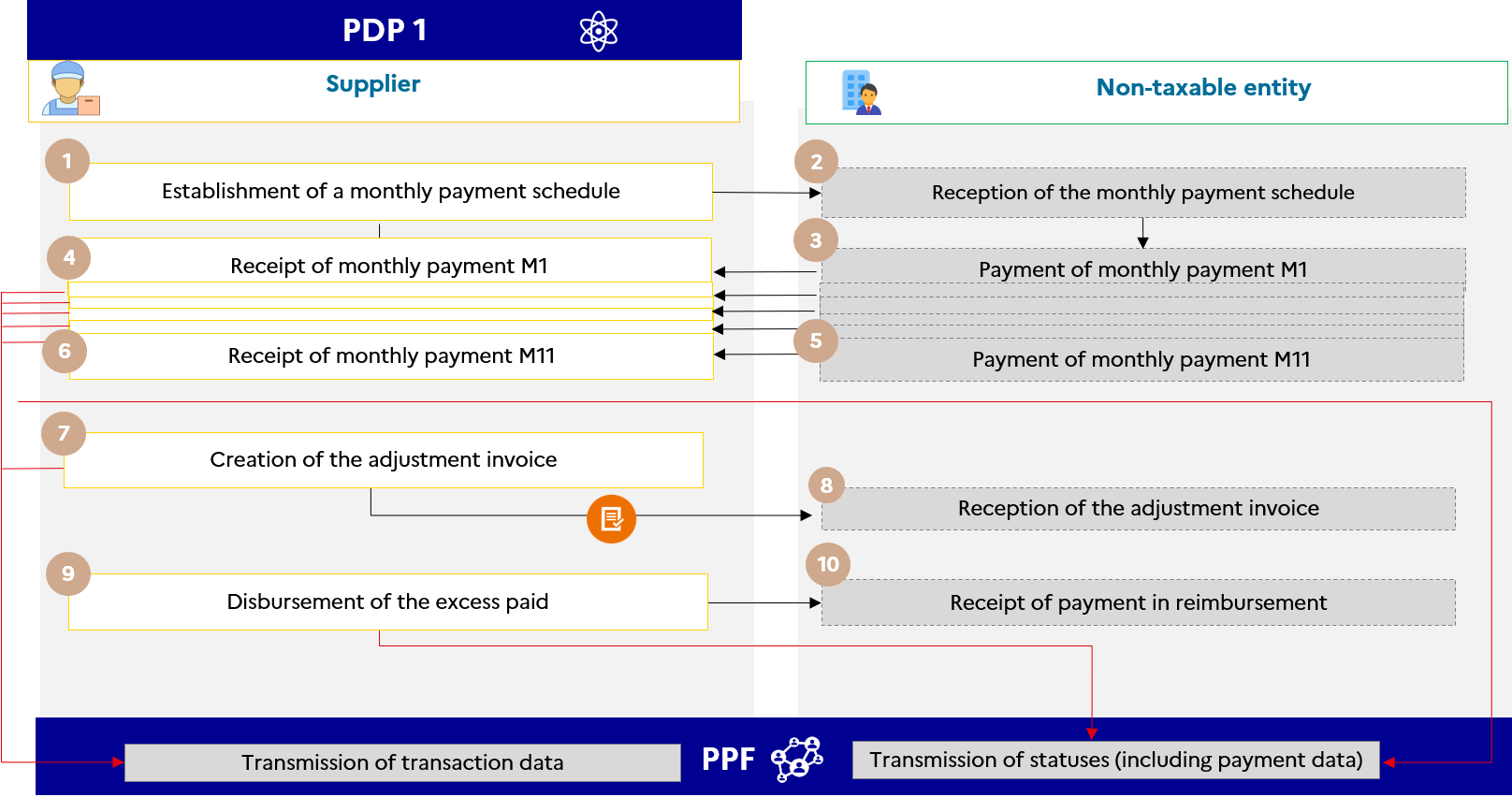

Figure 36 : Monthly payments and overpayments in a B2C transaction (option 2.a)

The specifics for forwarding invoicing/transaction and payment data are :

* Forwarding of e-reporting of the cumulative transaction data (flow 10.3) and payment data (flow 10.4) relating to the monthly payments received
* Raising of an adjustment invoice to the customer (outside the circuit) indicating the actual consumption and the total amount excluding VAT and the VAT amount
* In parallel, forwarding of net (negative) e-reporting equal to the amount of the adjustment invoice minus the prepayments
* Forwarding of payment data (flow 10.4) including the amount disbursed, corresponding to the overpayment shown on the adjustment invoice.

Case 2-b : The adjustment invoice shows an overpayment (option for the supplier to pay VAT on debits) :

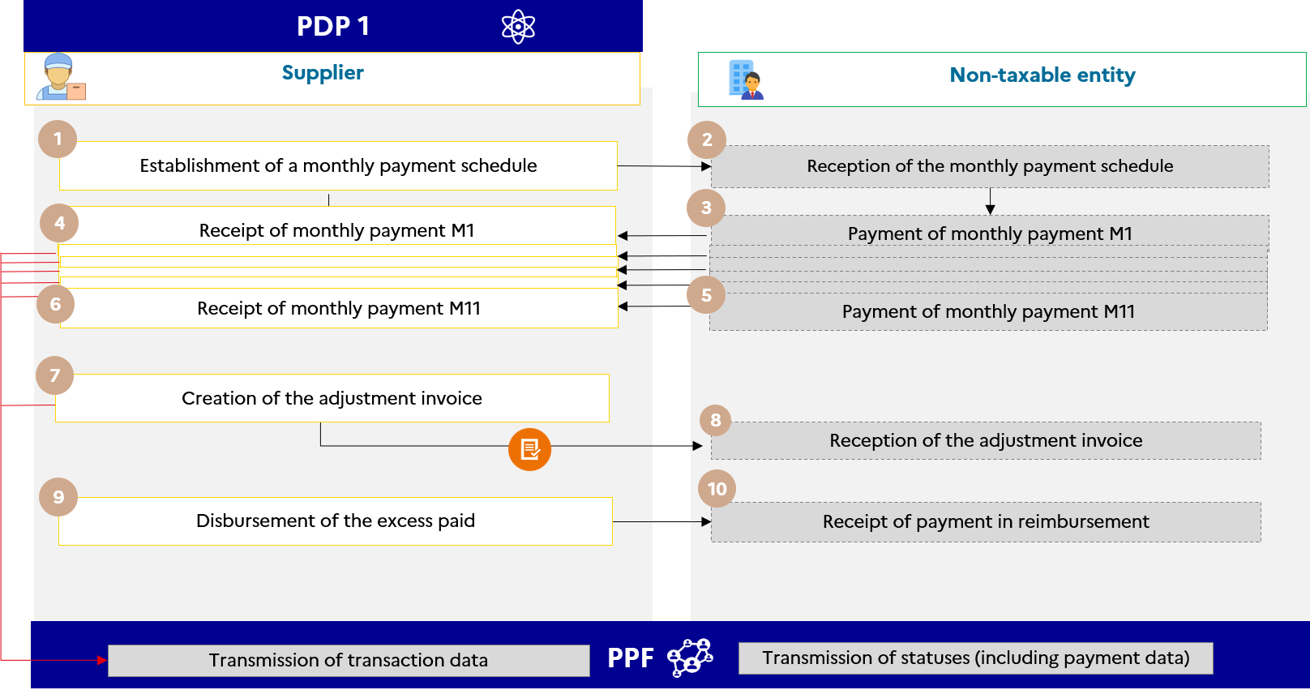

Figure 37 : Monthly payments and final overpayments in a B2C transaction (option 2.b)

**If the supplier has opted for VAT on debits** : the adjustment invoice showing the amount that is overpaid in negative will be taken into account. No payment data will be transmitted despite the overpayment.

The specifics of invoicing/transaction data transmission are :

* Forwarding of e-reporting of the cumulative transaction data (flow 10.3) relating to the monthly payments received
* Issue of an adjustment invoice to the customer (off-circuit).

### Case 33 : Transactions subject to the VAT margin scheme

Principle :

In the VAT margin scheme, the VAT is not calculated on the selling price, but on the **difference between the selling price and the purchase price**. The amount of VAT margin scheme is not included on the invoice, which poses a problem for e-invoicing.

The VAT margin scheme shall apply to transactions referred to in **Article 266** **1 (e)** [travel agencies and tour operators] and to Articles **268** [building site] and **297 A** [second hand goods, works of art, collectibles or antiques] of the general tax code.

E.g.

A travel agent invoices the organisation of a seminar (flight - hotels - meeting rooms) to a taxable entity as a single service.

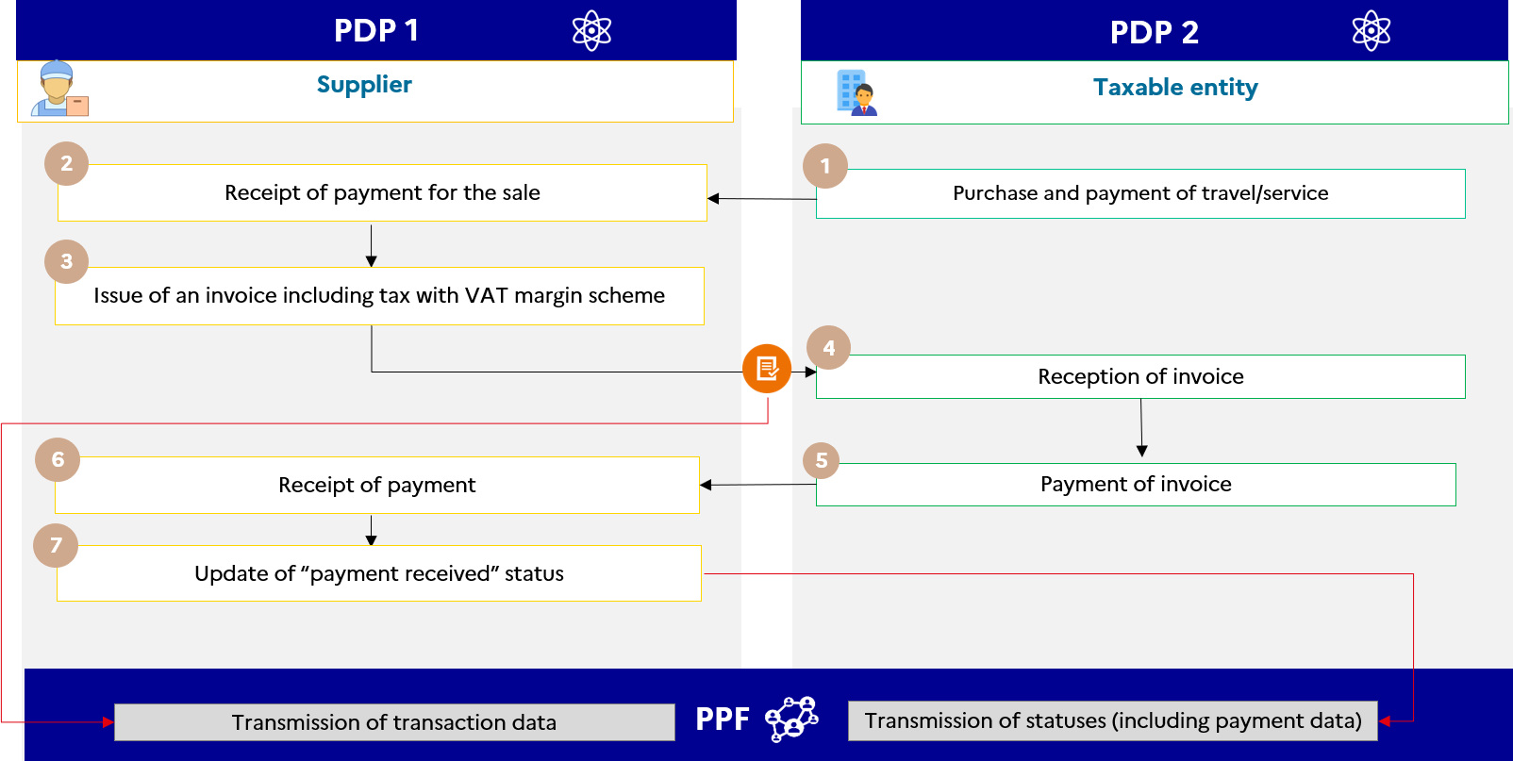

Figure 38 : Transactions subject to the VAT margin scheme

The data specifics and associated management rules for e-invoicing are :

* Management rule (G1.56) : VAT margin scheme
* VAT type code (BT 118) : I
* Code of grounds for VAT exemption (BT-121) : VATEX-DOM-/F/I/J
* VAT type taxable base (BT-116) : the selling price including VAT (entered in place of the base amount excluding VAT) as provided in BT-112
* VAT amount of the invoice (BT-110) : nil

the specifics for forwarding invoicing and payment data are :

* Transmission of invoice (flow 2)
* Transmission of the “payment received” status of the invoice life cycle (flow 6), as supplies of services

**A travel agency charges flight+hotel to a private individual :**

The data specifics and associated management rules for e-reporting are :

* Transaction category : Transactions subject to a special scheme for which the VAT margin scheme has been applied (TMA 1) ;
* VAT type taxable base : amount of the margin excluding VAT ;
* VAT amount of the invoice equal to the amount of the VAT margin scheme.

### Case 34 : Partial receipt of payment and cancellation of receipt of payment

Each partial receipt of payment (e.g. in the event of an prepayment) must be reported with a life-cycle flow with the status “received”. The “amount” field will show the amount received.

In case of cancellation of receipt of payment after a reconciliation error or fraudulent payment (embezzlement, theft, hacking etc.), it will be possible to issue a life cycle flow with the status of "payment received" for a negative amount (in the amount field).

### Case no. 35 : Author’s notes

|  |  |  |
| --- | --- | --- |
| **TRANSACTIONS BY THE AUTHOR** | **PAYER INSTITUTION** | **APPLICABLE MECHANISM (EI/ER)** |
| Collection of copyright | Publishers, copyright collection and distribution agencies or producers. | Gives rise to VAT holdback by the payer   * E-reporting by the paying institution (no invoice but a statement of rights for the benefit of the author) |
| Collection of copyright | Other than publishers, copyright collection and distribution agencies or producers. | Does not give rise to VAT holdback by the payer   * E-invoicing by the author (invoice issued by author) if B/G customer * E-reporting if customer C (e.g. a non-taxable association). |
| Other transactions not subject to holdback | - | * E-invoicing by the author (invoice issued by author) if B/G customer * E-reporting by the author if client C. |

* **Rights statements** do not fall within the domain of e-invoicing.
* **Transactions giving rise to holdback of VAT by publishers, copyright collection and distribution agencies and producers** fall within the **e-reporting** domain of these enterprises. Therefore, there is no need for a dedicated invoicing framework.
* For **copyrights** that are **not paid by these bodies**, the **authors** are liable for VAT unless they benefit from the basic exemption regime and are subject, like any taxable entity, to the **e-invoicing / e-reporting** obligations, depending on whether or not their client is a taxable person.
* For **transactions other than copyrights**, authors remain subject to the common law regime and may fall within the **e-invoicing** or **e-reporting** domain.

The case of author's notes is presented to clarify the application of electronic invoicing and e-reporting to this use case. No additional obligation is anticipated in relation to Article 285 bis of the French General Tax Code (CGI).

### Case 36 : Transactions subject to professional secrecy and exchange of sensitive data

In order to comply with transactions subject to professional secrecy (see Article 226-13 of the French Criminal Code - in particular banking secrecy under Article L. 511-33 of the French Monetary and Financial Code or business secrecy under Article L. 151-1 of the French Commercial Code) as well as sensitive data covered by Ministerial Instruction No. 900/ARM/CAB/NP of 15 March 2021, the operators concerned may submit generic information concerning the precise name of the good or service provided, which must be mentioned in the "item name" field (BT-153) of flows 2 and flow 1.

However, to answer their obligations with regard to their client, they must specify the transaction achieved. This information can be transmitted via the BT-154 tag in Flow 2, thus enabling both transaction parties to have the details of the information.

Only parties mentioned on the invoice will have access to this field, which is only present in Flow 2.

Only the BT-153 field with very general information will be transmitted to the tax authority.

# Contacts

Please direct your questions/comments to the project teams :

* NEW CONTACT !! [aife.economie.gouv.fr/formulaire-de-contact-ppf](https://aife.economie.gouv.fr/formulaire-de-contact-ppf).

1. The subscription solution is being reviewed.
2. The subscription solution is being reviewed.